MySQL Database

Handbook

6/5/2016

Computer Science Middlesex University London

Povilas Urbonas

Contents

1 - Introduction to Databases 4

2 - Getting a MySQL Server 4

3 - Creating a Database 4

4 Show and SELECT 6

5 Basic Rules for SQL Statements 7

6 - Getting Multiple Columns 8

7 - DISTINCT and LIMIT 9

8 - Sorting Results 11

9 - Sort Direction 14

10 - Basic Data Filtering and WHERE 17

11 Advanced Filtering Using AND and OR 19

12 - Are you IN or are you NOT IN 20

13 - How Search Engines Work 23

14 - More on Wildcards 24

15 - Regular Expressions 24

16 - Creating Custom Columns 26

17 – Functions 28

18 - More on Aggregate Functions 29

19 - GROUP BY 31

20 – Subqueries 32

21 - Another Subquery Example 34

22 - How to Join Tables 35

23 - Outer Joins 36

24 – UNION 37

25 - Full-Text Searching 38

26 - INSERT INTO 39

27 - How to Insert Multiple Rows 41

28 - UPDATE & DELETE 42

29 - CREATE TABLE 43

30 - NOT NULL & AUTO INCREMENT 44

31 - ALTER DROP RENAME TABLE 46

32 – View 48

33 - Final 52

## 1 - Introduction to Databases

SQL is the language databases use

MySQL is a program that understand SQL

Other software, but MySQL is the best!

## 2 - Getting a MySQL Server

<https://x10hosting.com/>

* Username: codemara
* Your Domain: <http://codemarathoner.x10host.com/>

[povilas.urbonas85@gmail.com](mailto:povilas.urbonas85@gmail.com)

## 3 - Creating a Database

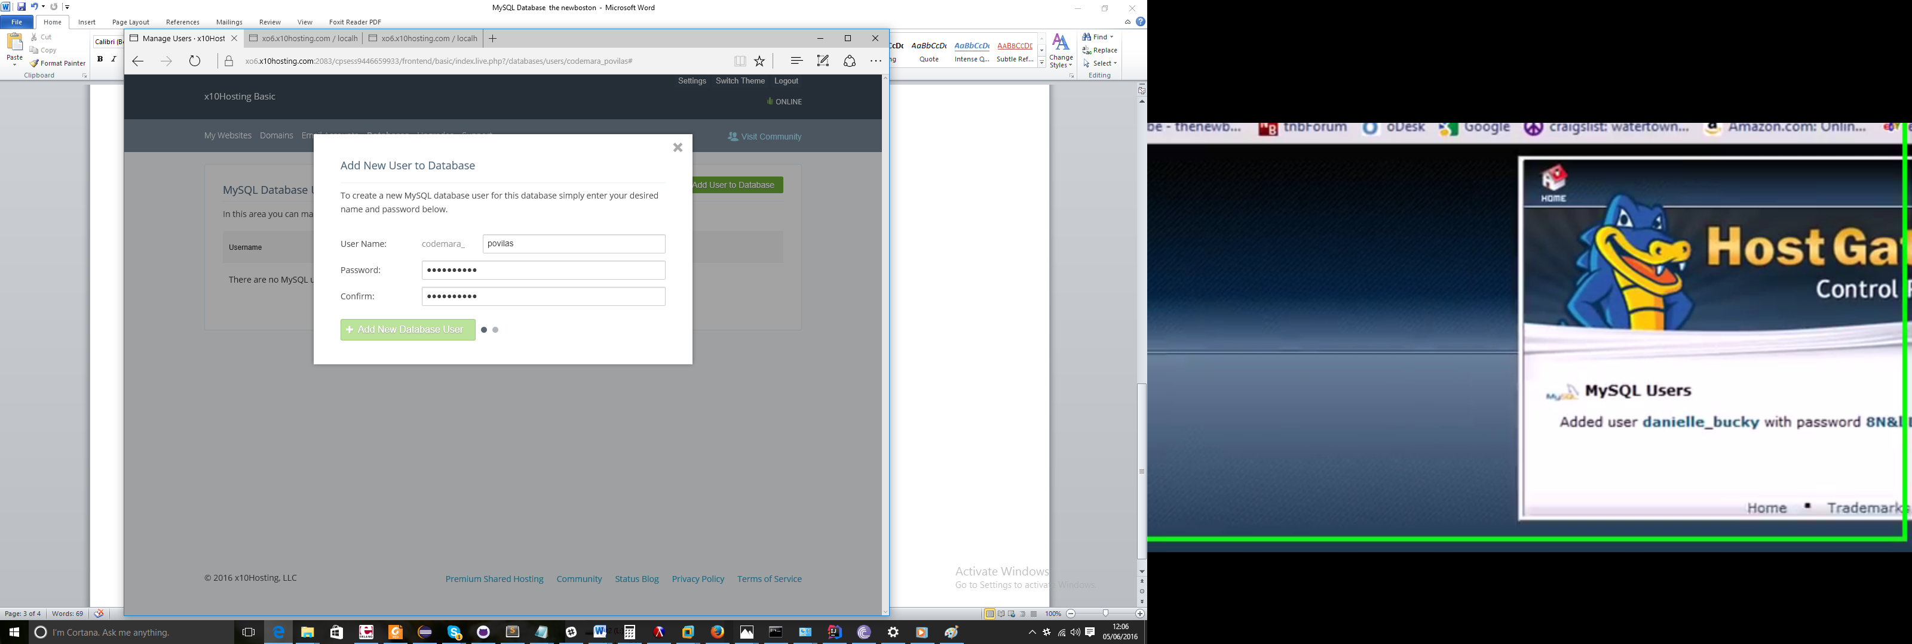

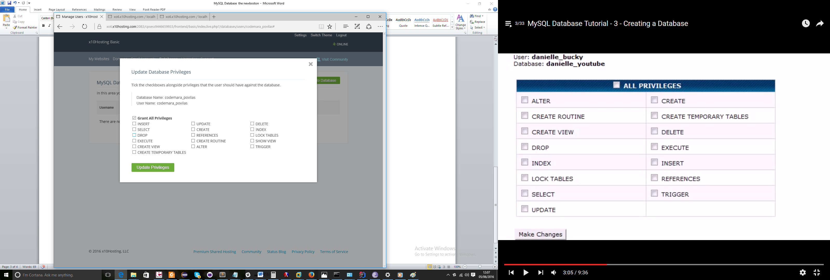

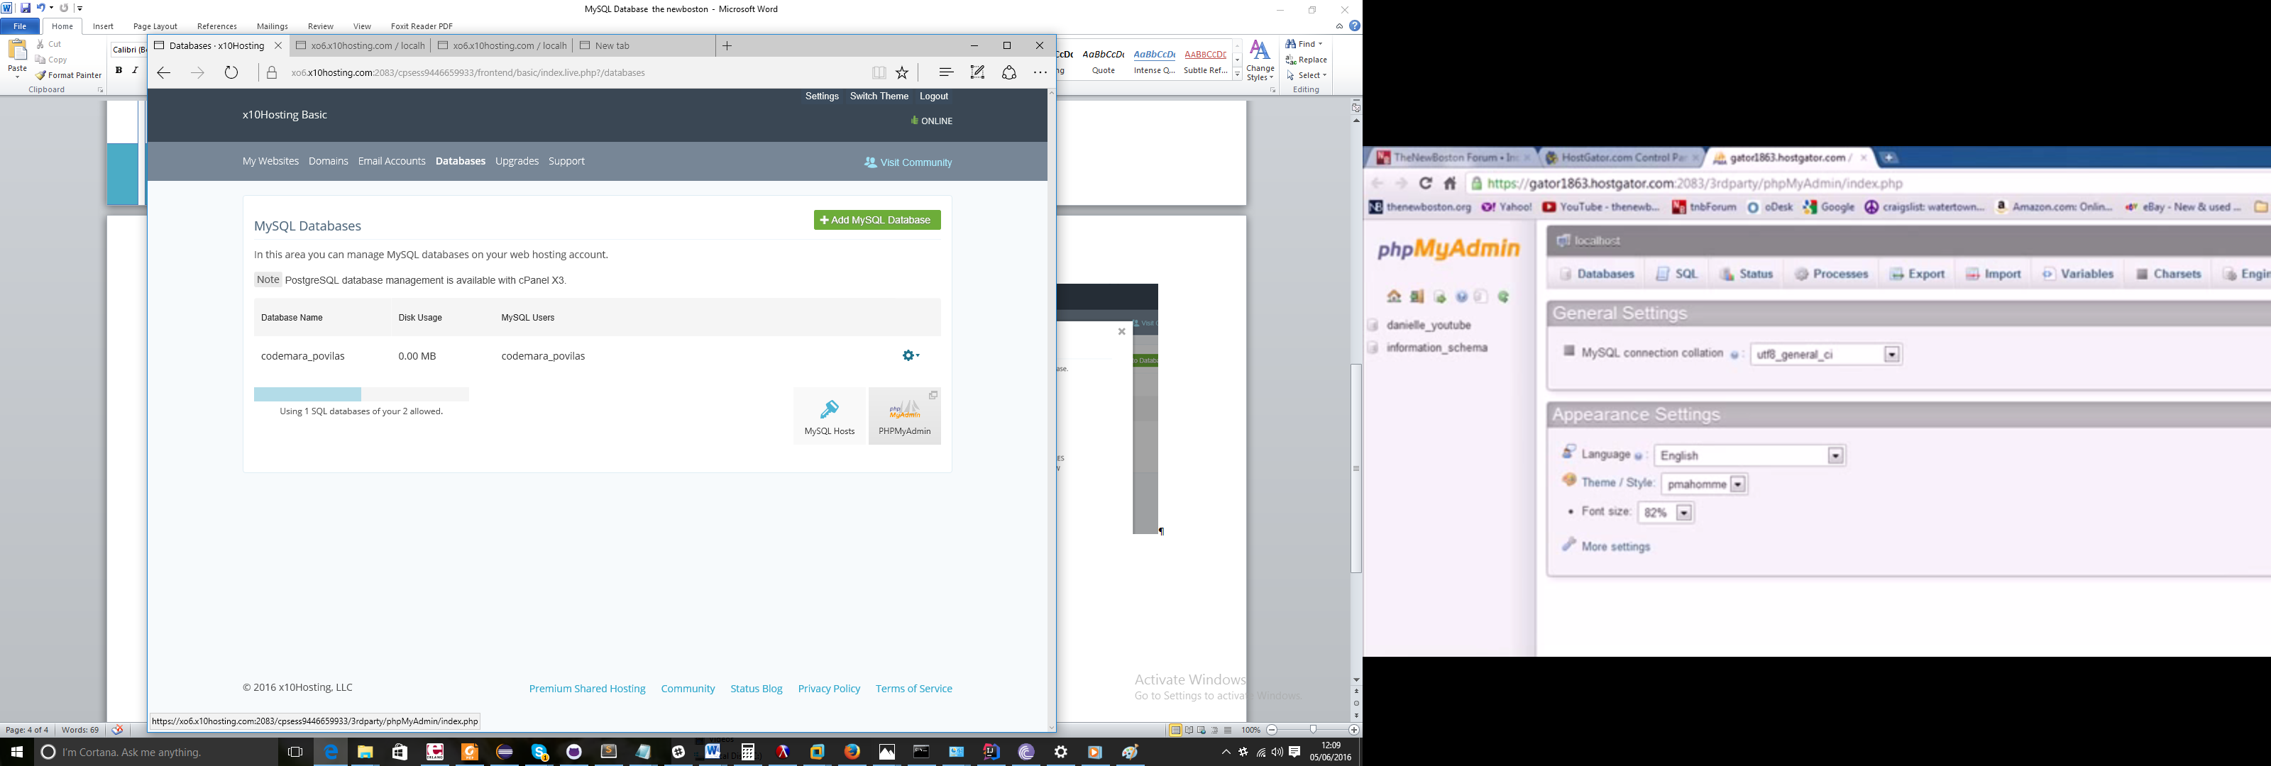

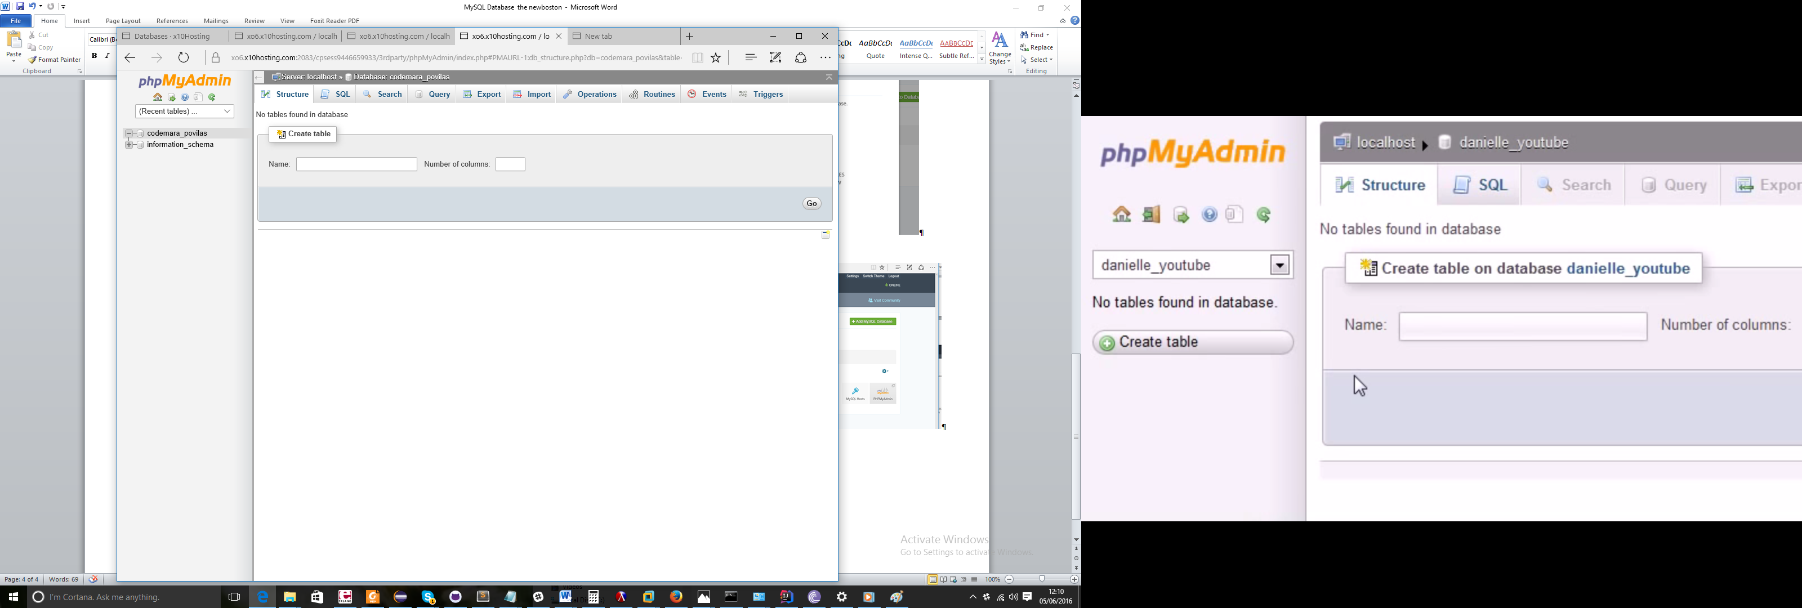

## 4 Show and SELECT

SHOW DATABASES

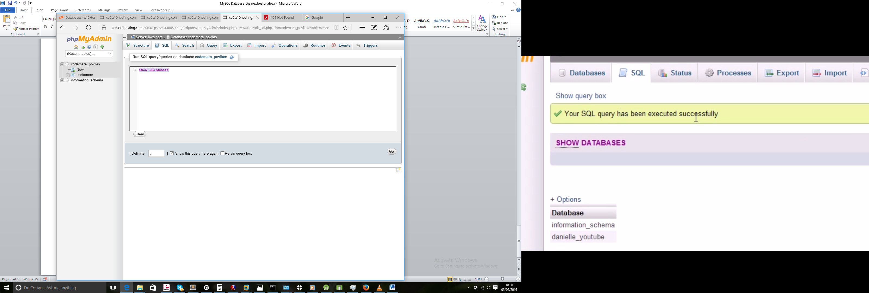

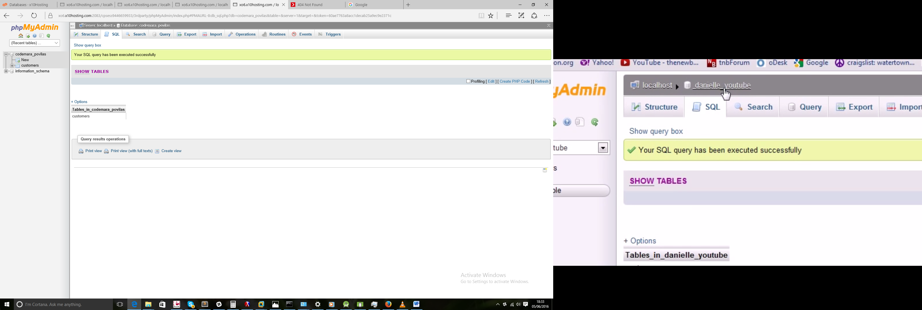

SHOW COLUMNS FROM customers

[SELECT](https://xo6.x10hosting.com:2083/cpsess9446659933/3rdparty/phpMyAdmin/url.php?url=http%3A%2F%2Fdev.mysql.com%2Fdoc%2Frefman%2F5.5%2Fen%2Fselect.html&token=60ae7763a8acc1decab25a9ec9e2371c) city FROM customers

## 5 Basic Rules for SQL Statements

**SELECT city FROM customers;**

**SELECT id FROM customers;**

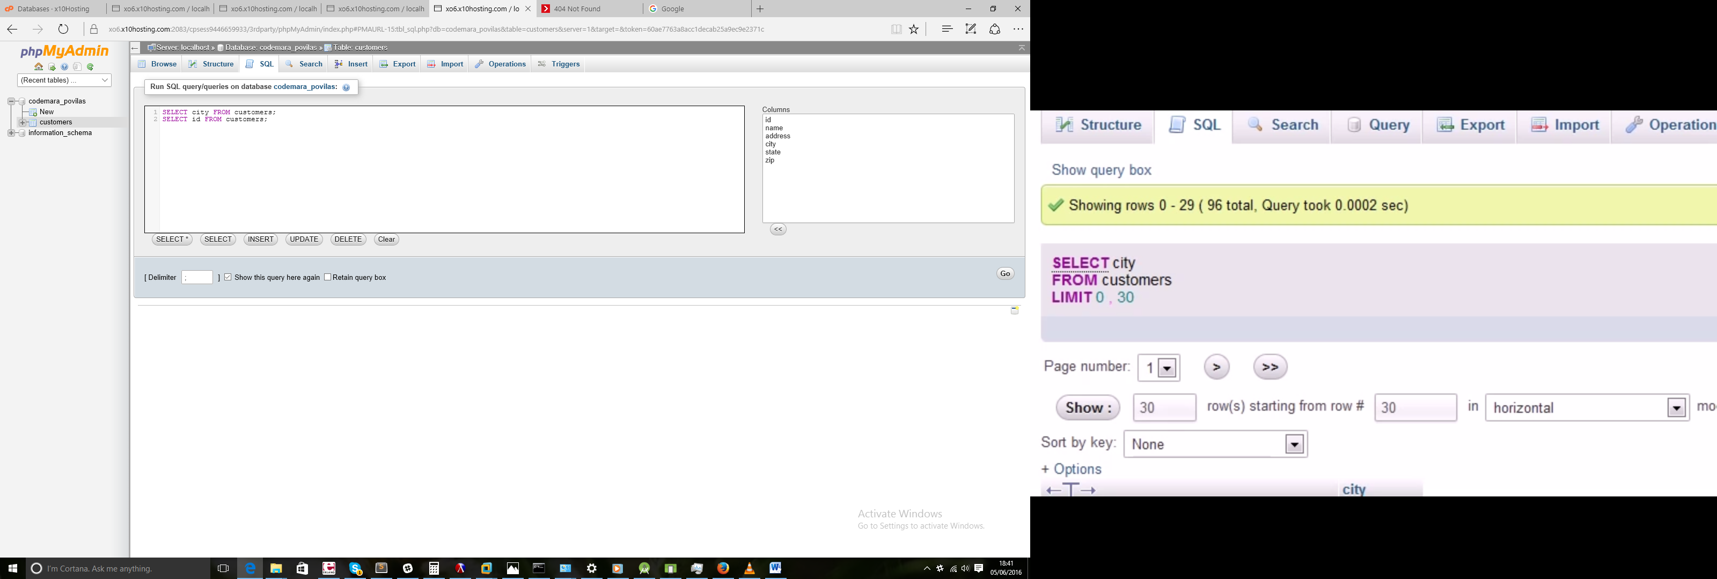

## 6 - Getting Multiple Columns

SELECT name, zip FROM customers

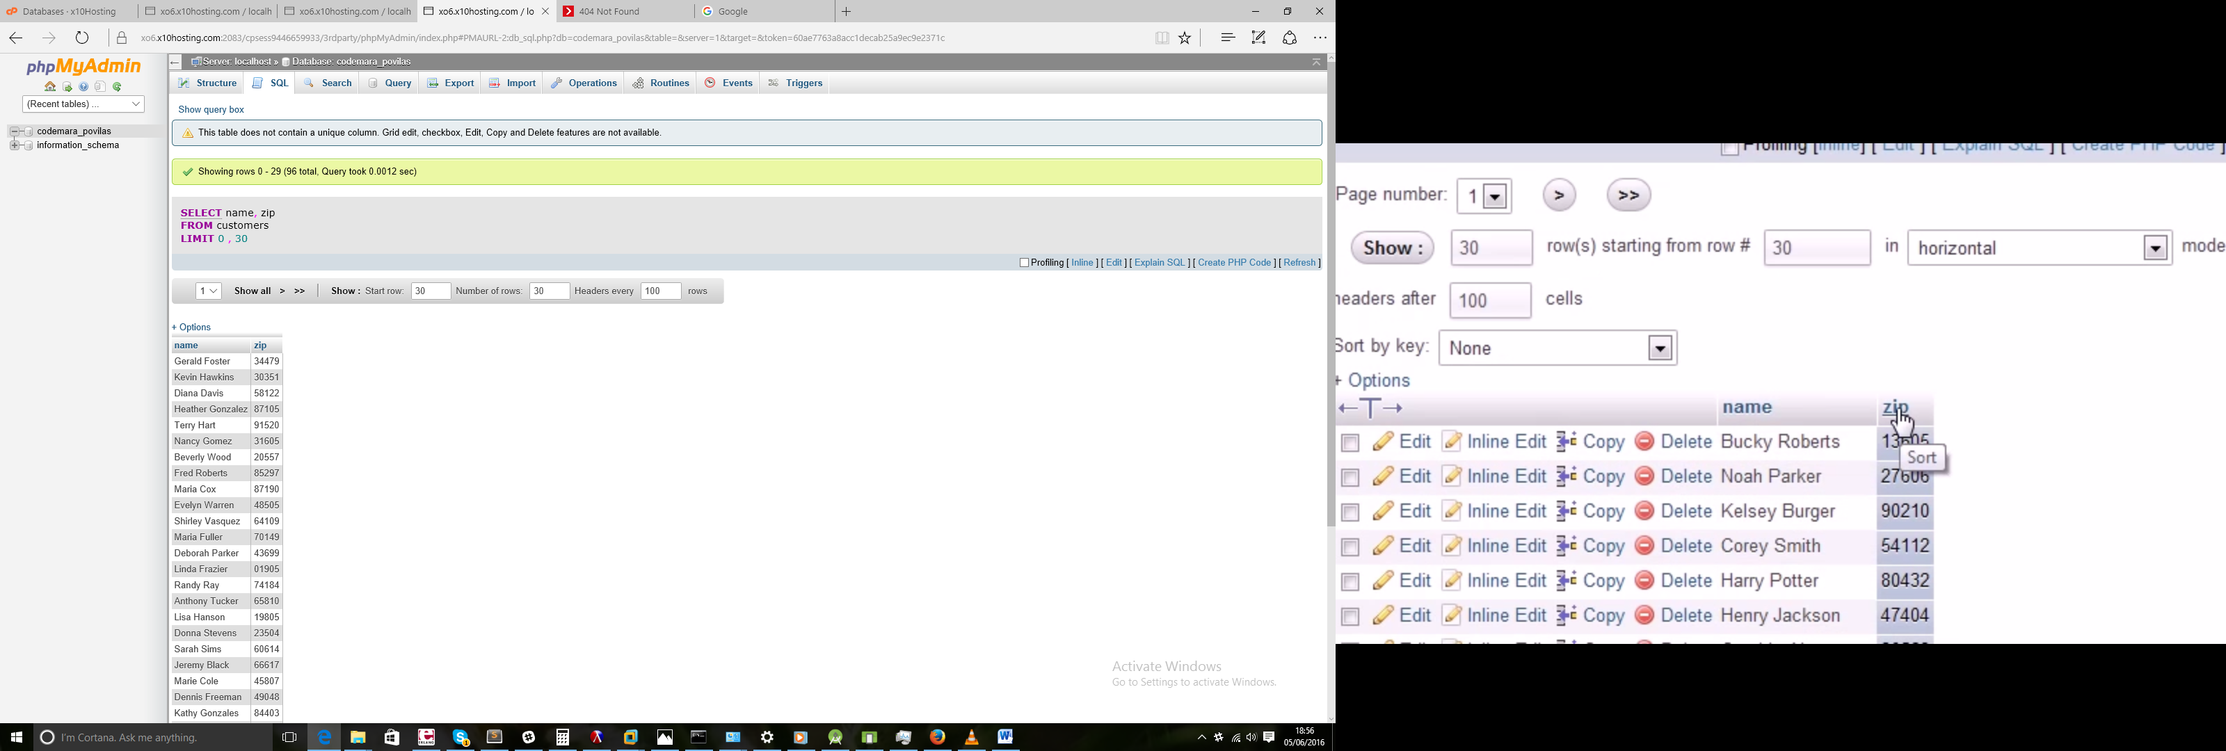

## 7 - DISTINCT and LIMIT

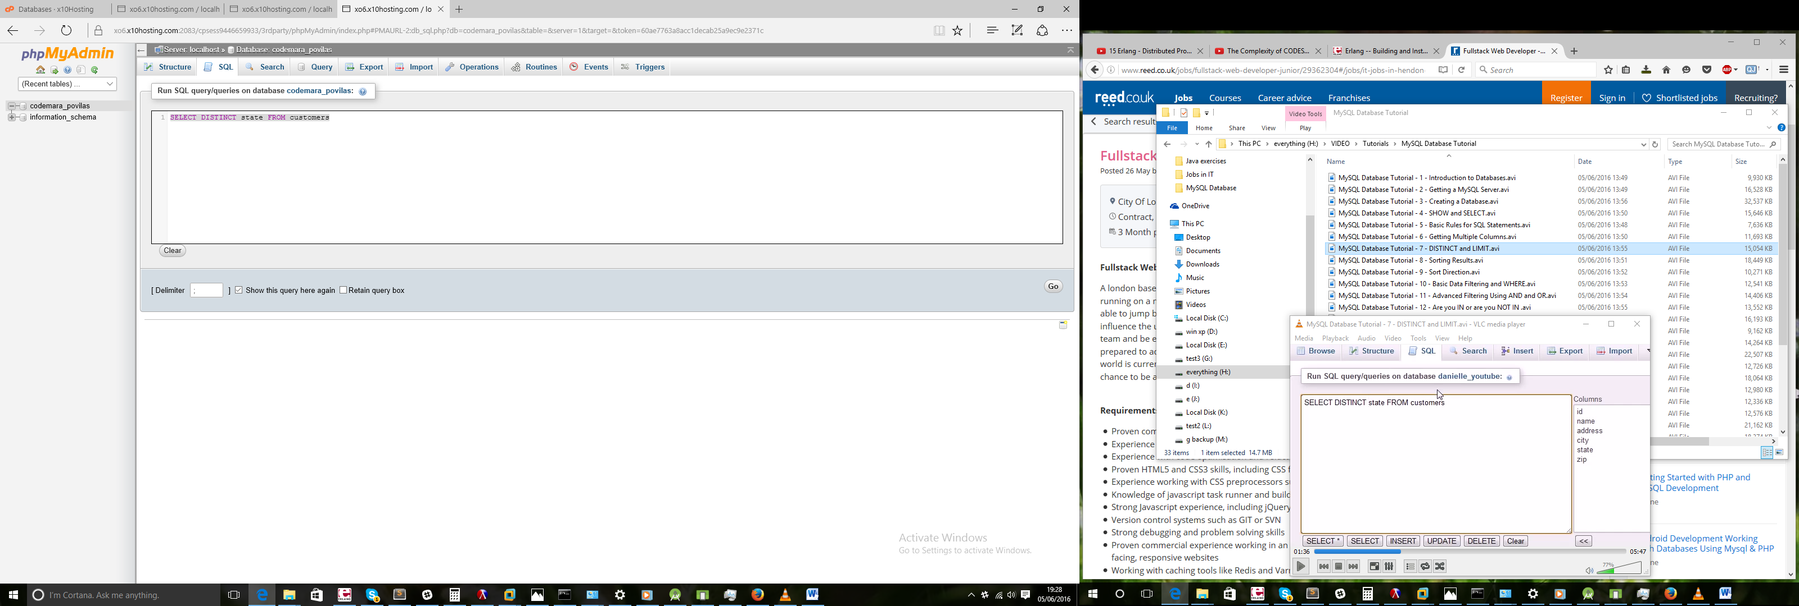

Not showing dublicates

SELECT id, name FROM customers

SELECT id, name FROM customers LIMIT 5

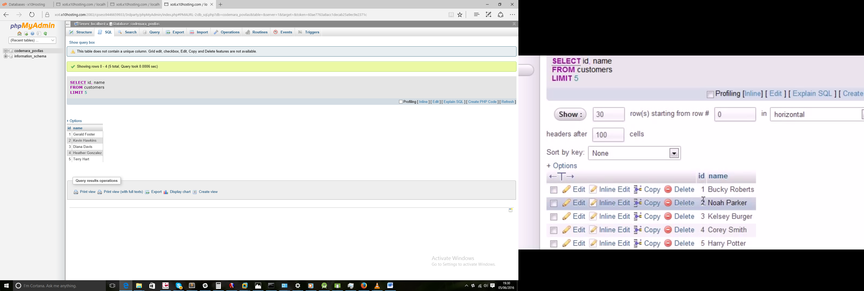

SELECT id, name FROM customers LIMIT 5, 10

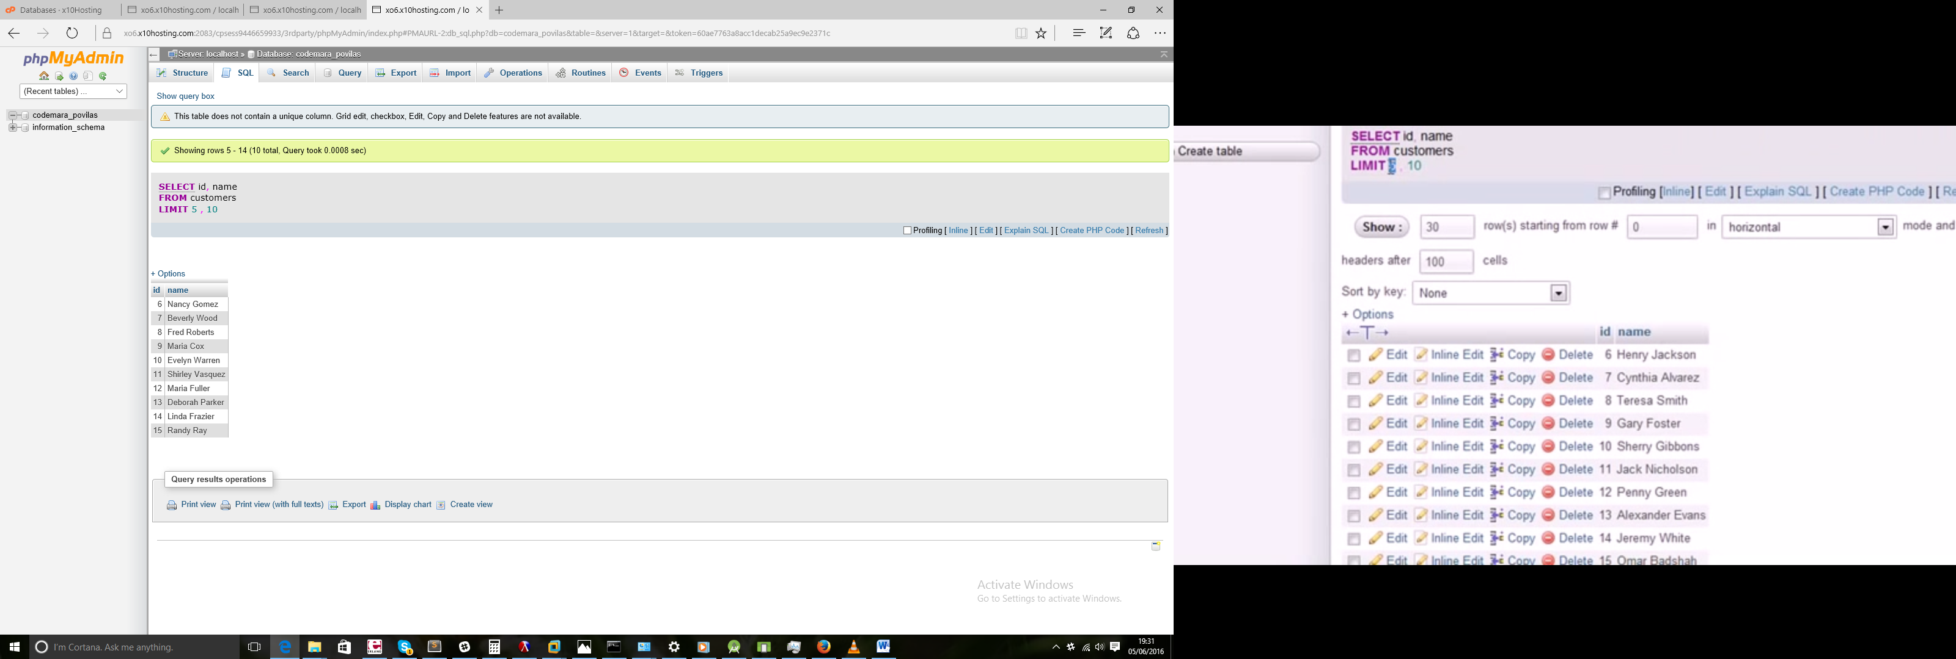

## 8 - Sorting Results

SELECT address FROM customers

SELECT customers.address FROM customers

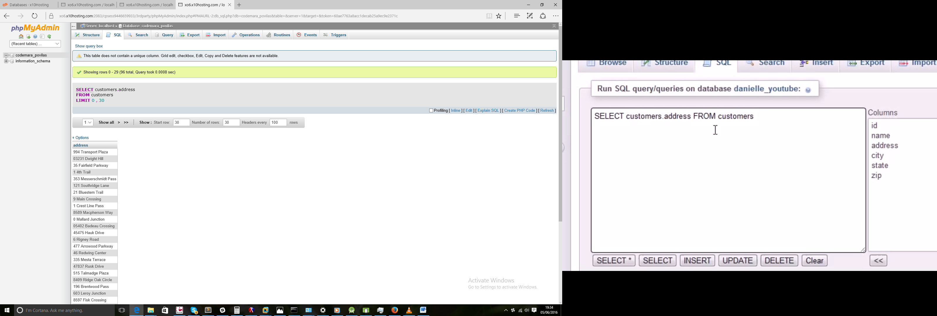

SELECT name FROM customers

SELECT name FROM customers ORDER BY name

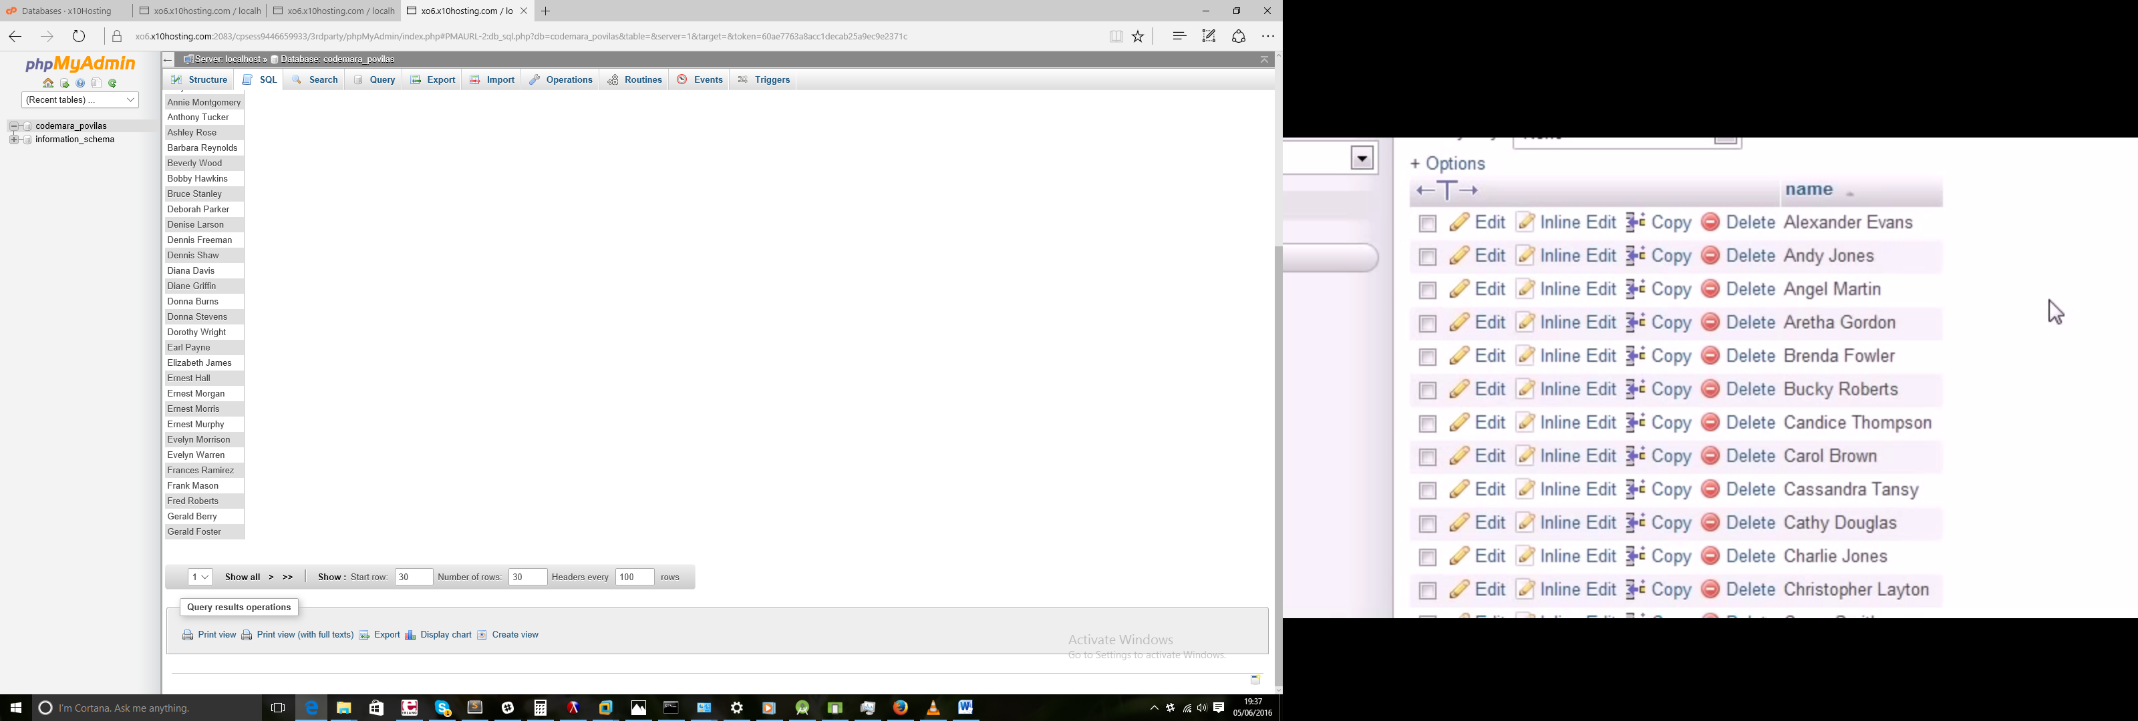

SELECT name, address FROM customers ORDER BY id

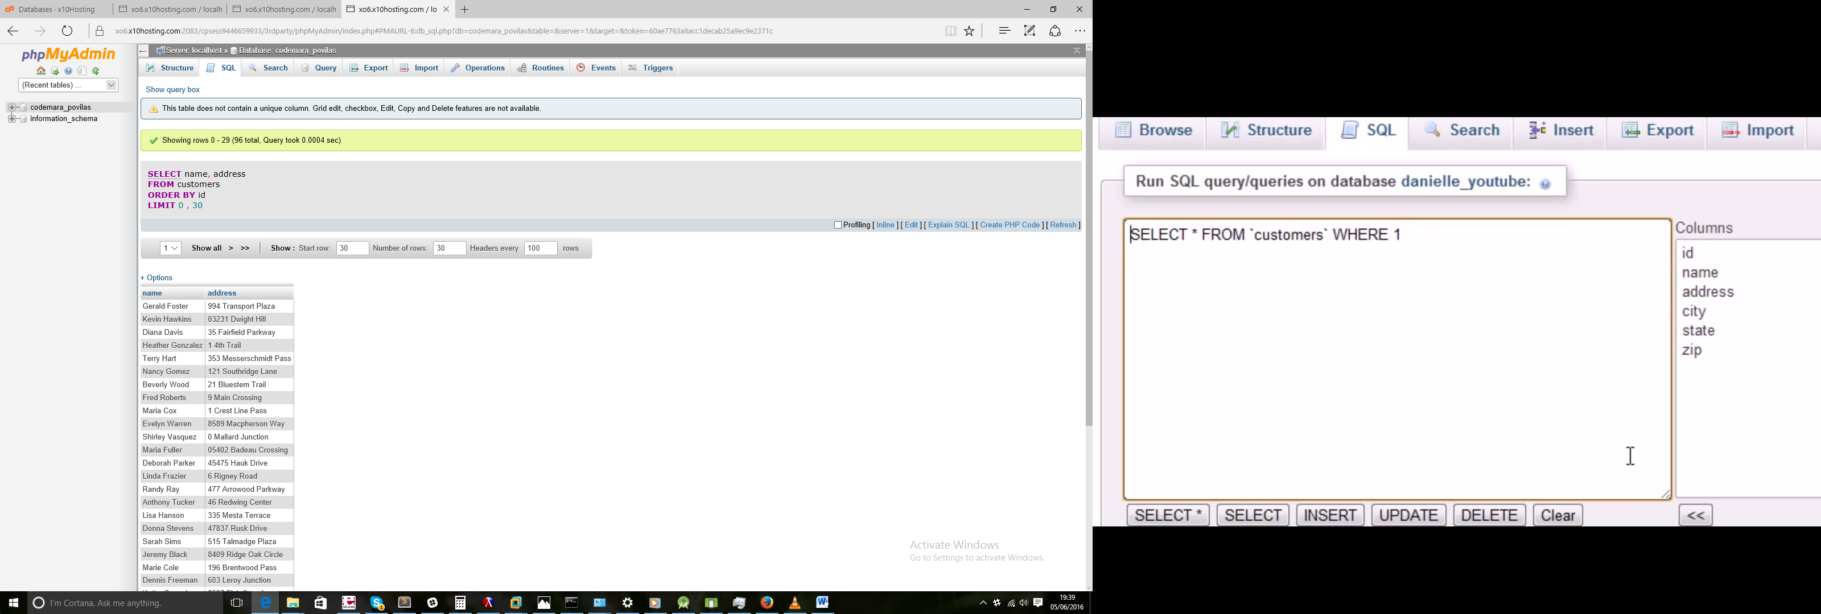

SELECT name, address FROM customers ORDER BY id

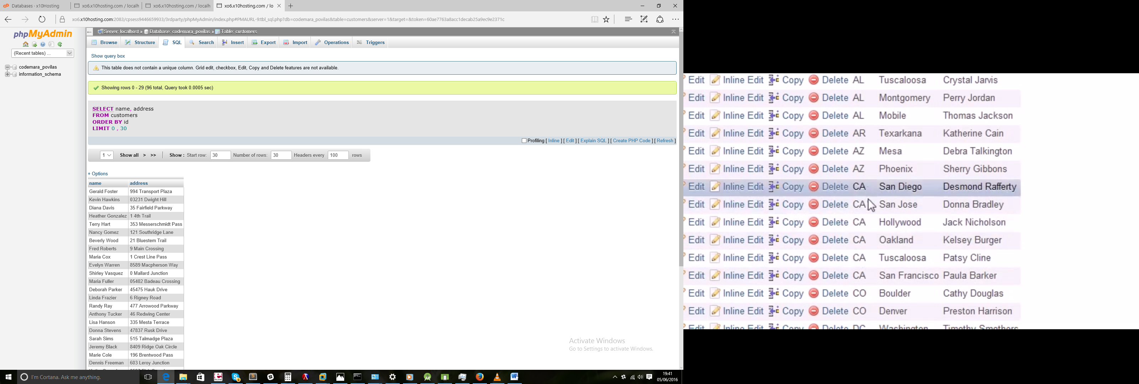

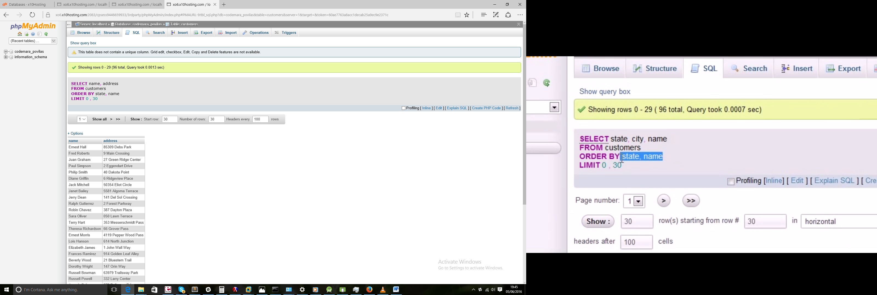

## 9 - Sort Direction

SELECT name,zip FROM customers ORDER BY zip

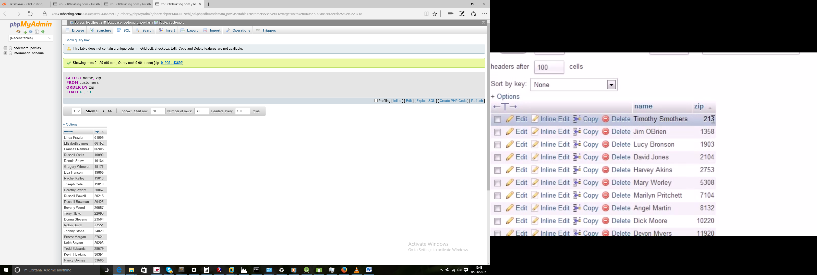

SELECT name,zip FROM customers ORDER BY zip DESC

(sorting hi to low)

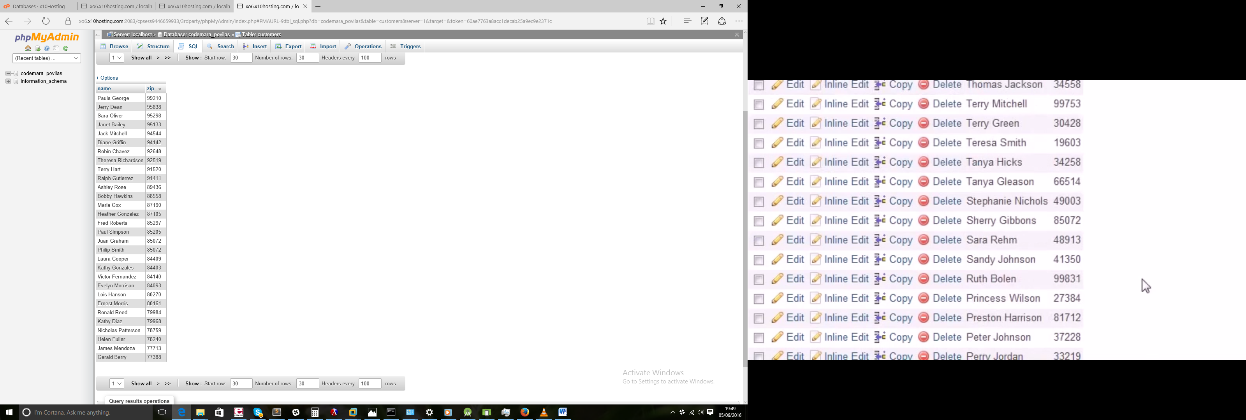

SELECT name,id FROM customers ORDER BY id

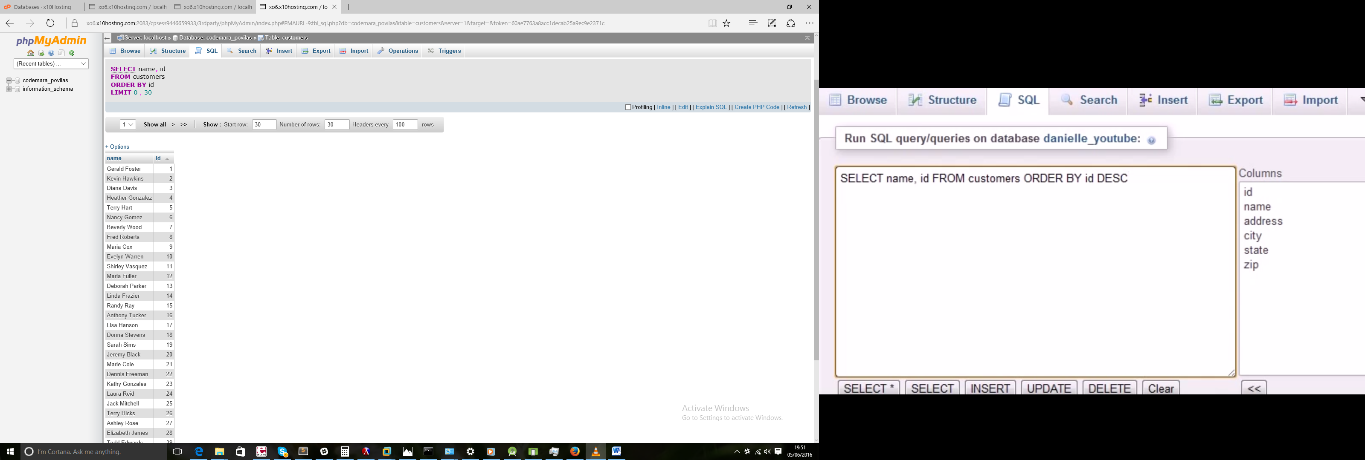

SELECT name,id FROM customers ORDER BY id DESC LIMIT 1

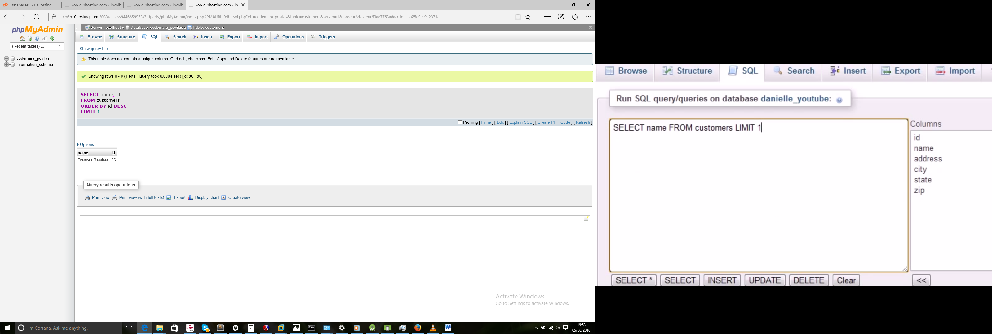

SELECT name FROM customers ORDER BY id DESC LIMIT 1

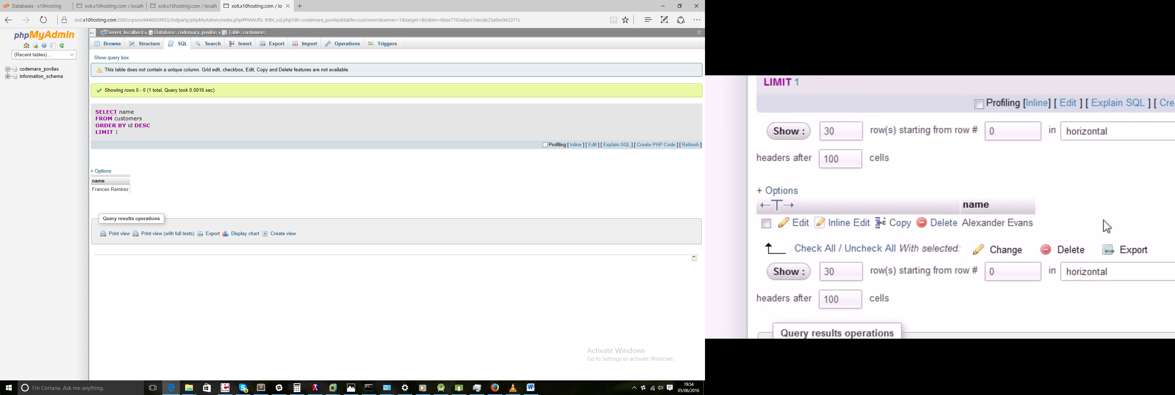

## 10 - Basic Data Filtering and WHERE

SELECT id, name FROM customers WHERE id=54

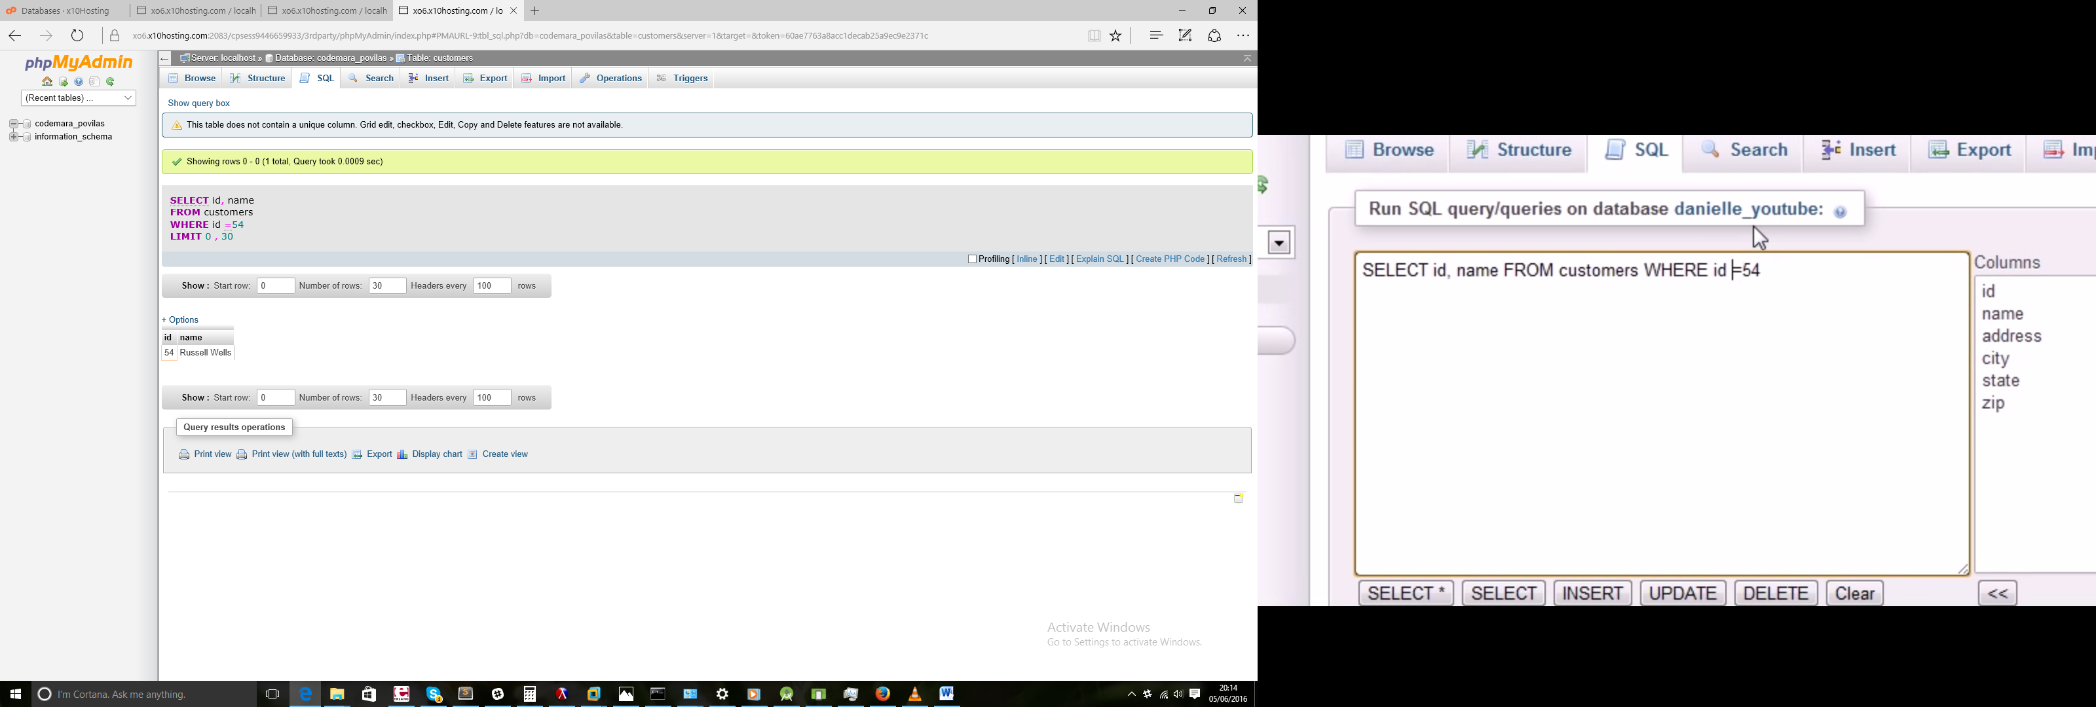

SELECT id, name FROM customers WHERE id !=54

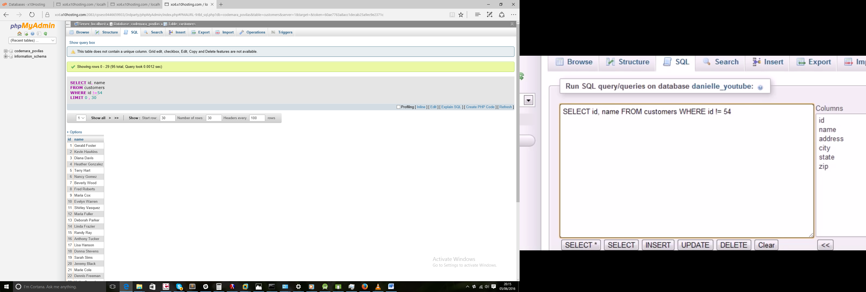

SELECT id, name FROM customers WHERE id <8

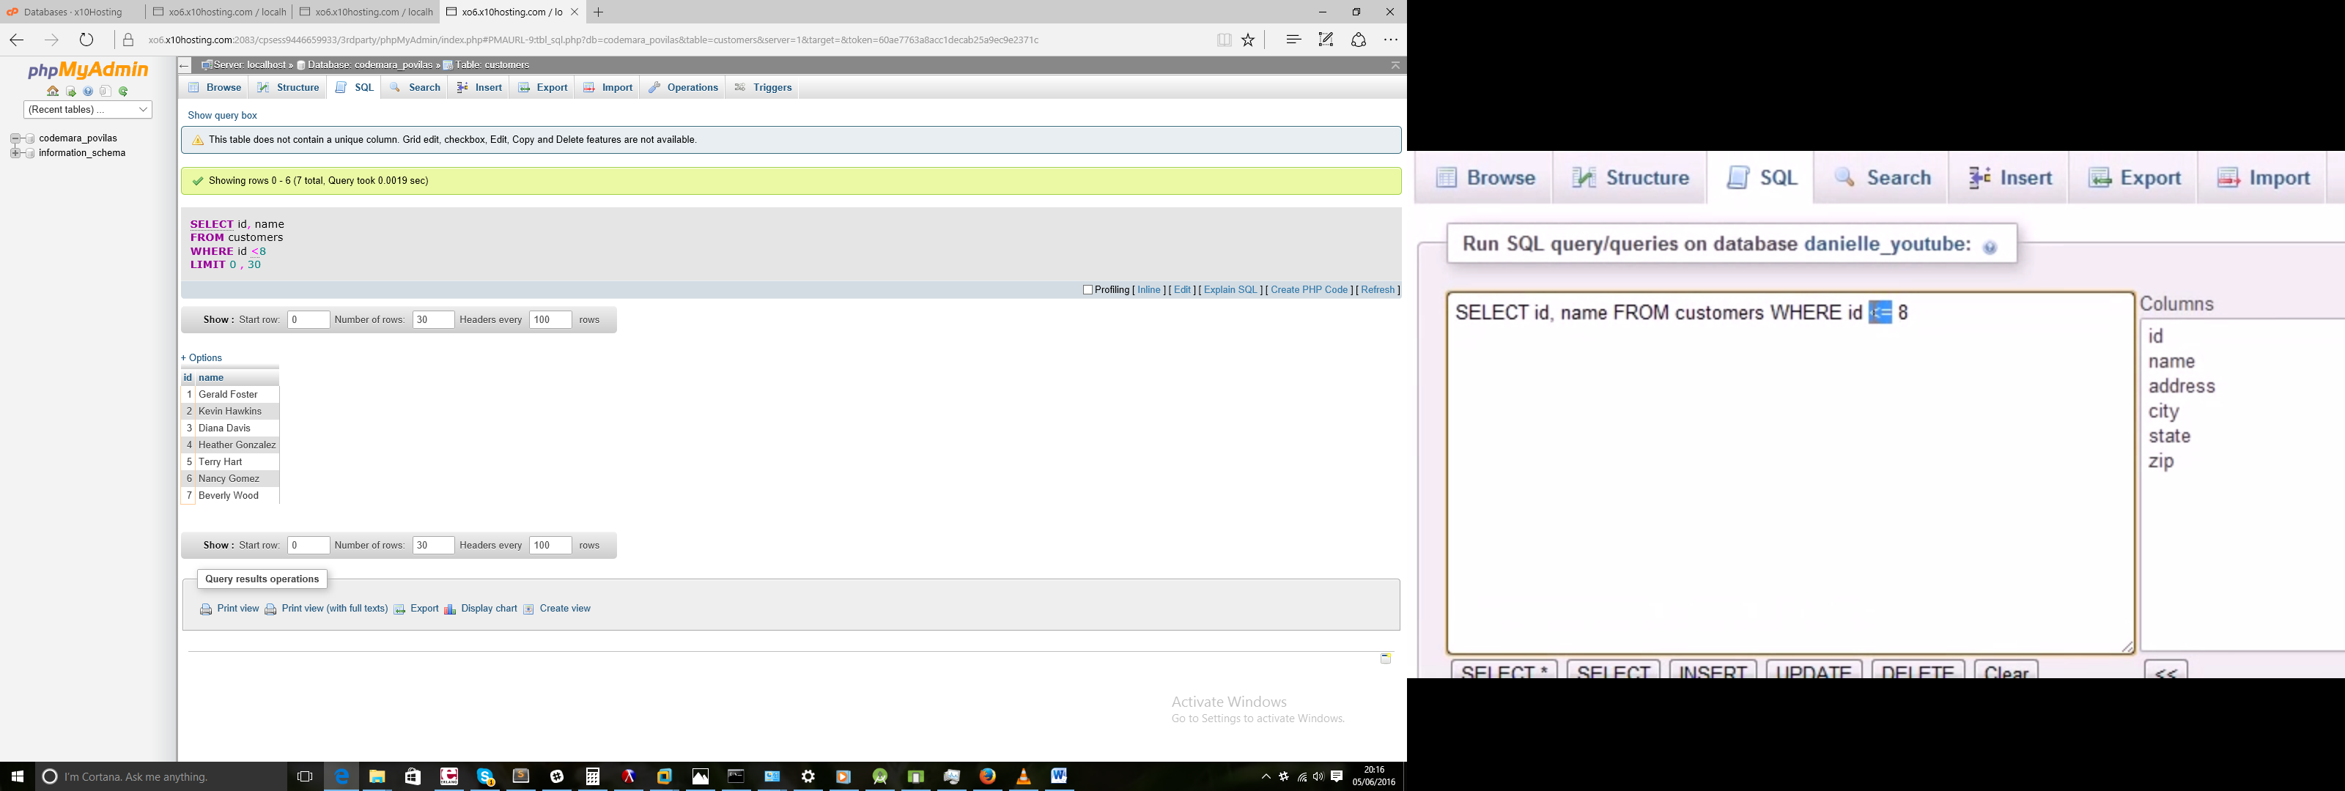

SELECT id, name FROM customers WHERE id BETWEEN 25 AND 30

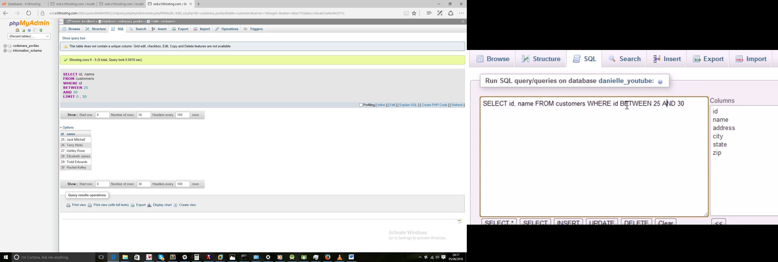

SELECT name, state FROM customers WHERE state = 'CA'

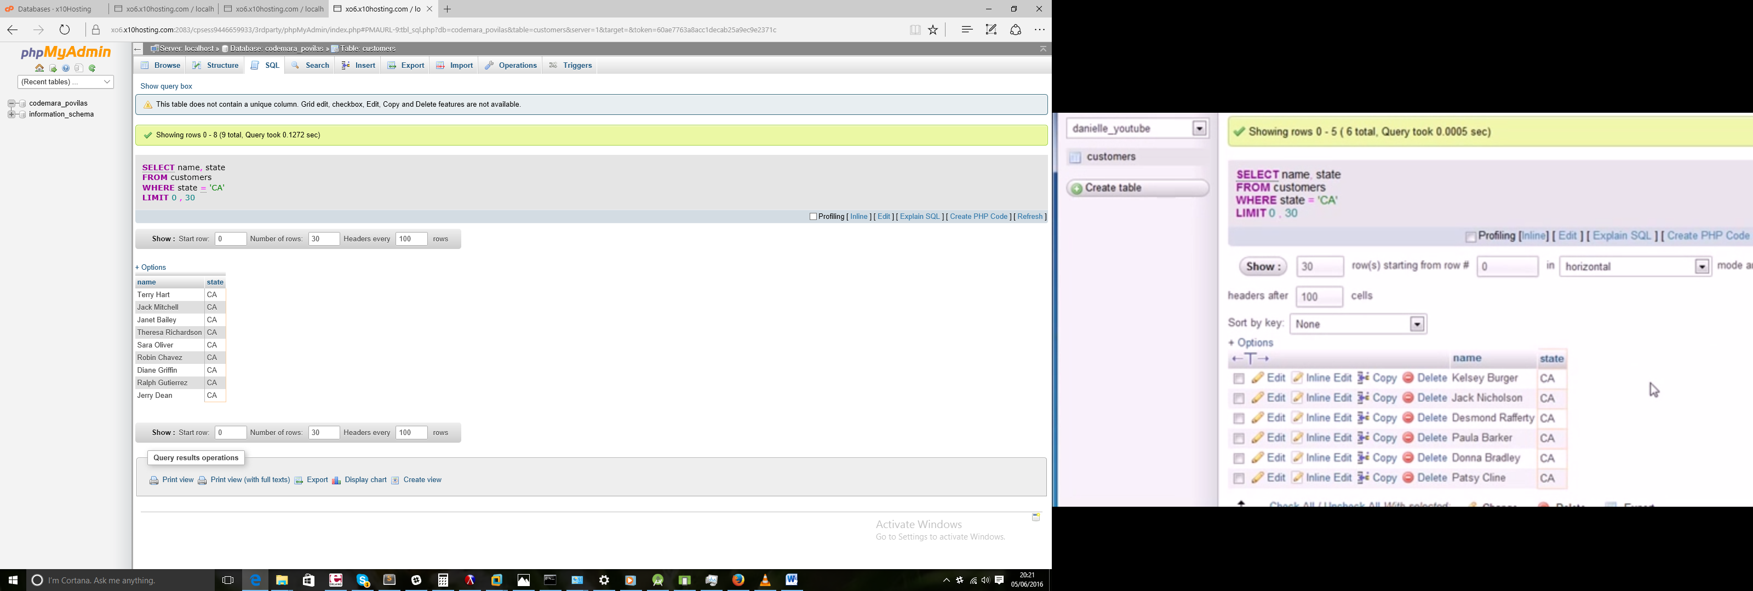

## 11 Advanced Filtering Using AND and OR

SELECT name, state, city FROM customers WHERE state='MA' AND city='Lynn'

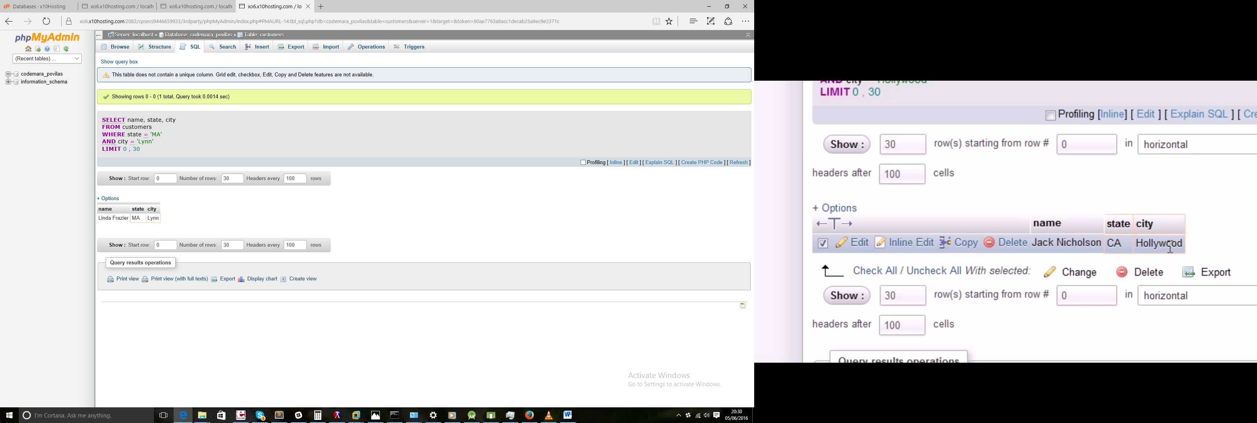

SELECT name, state, city FROM customers WHERE state='FL' OR city='Tulsa'

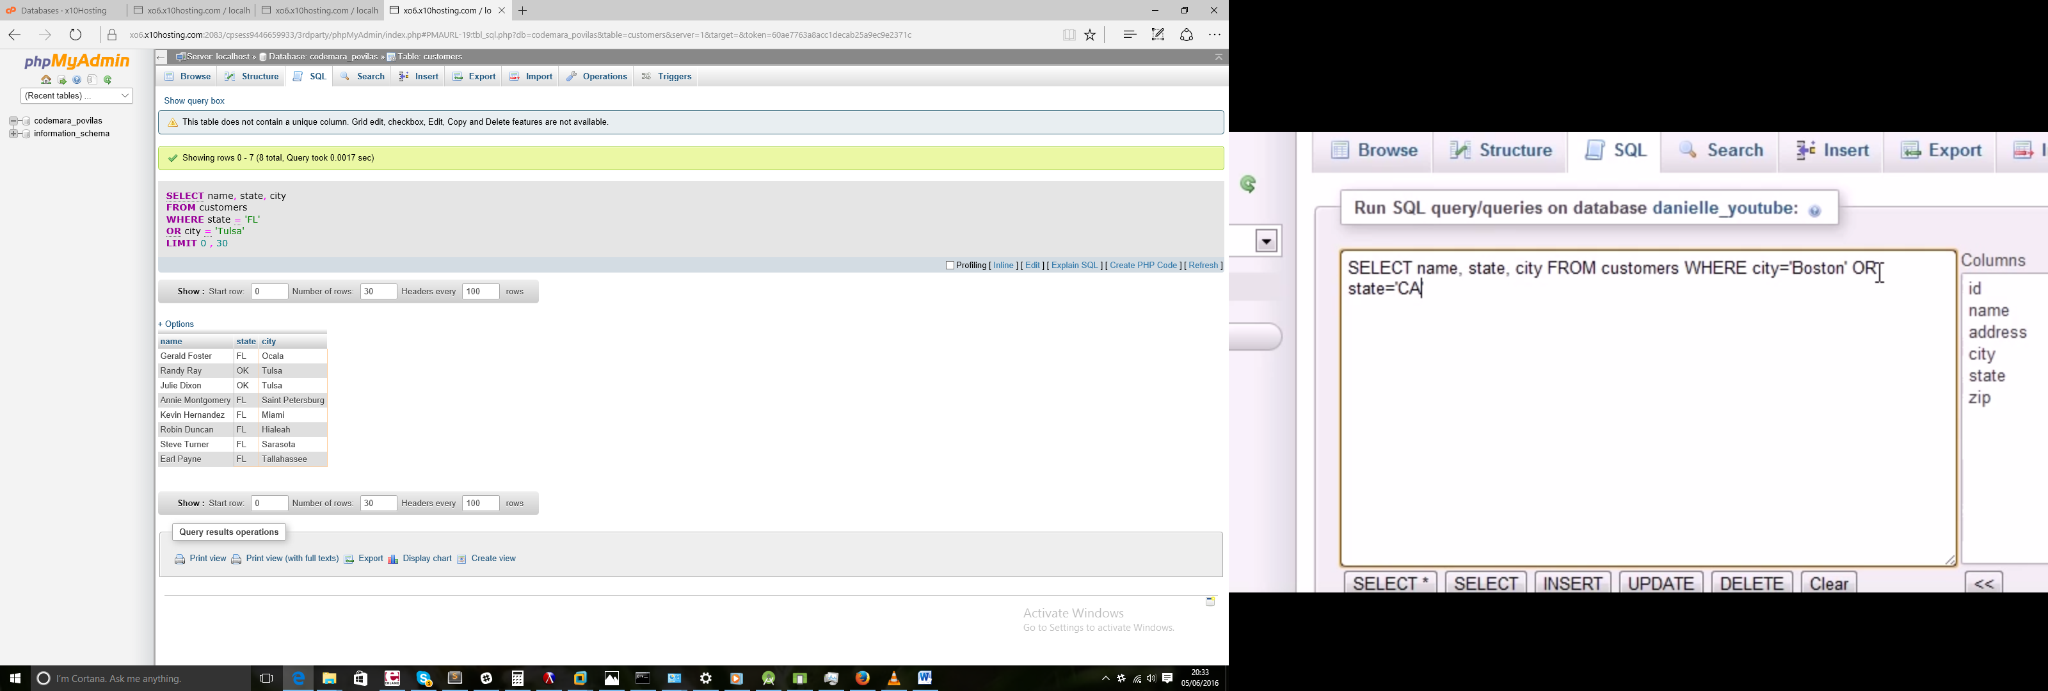

SELECT name, id, city FROM customers WHERE (id=1 OR id=2) AND city='Atlanta'

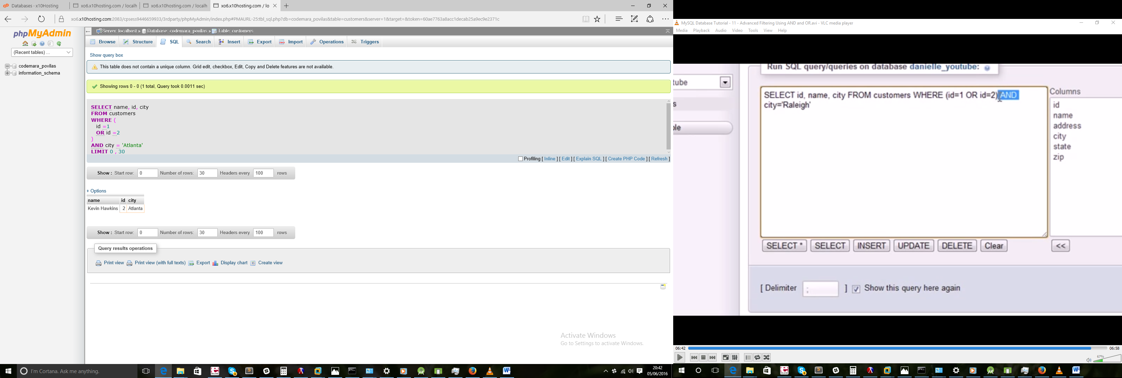

## 12 - Are you IN or are you NOT IN

SELECT name,state FROM customers WHERE state='FL' OR state='' OR state='NM' OR state='ND'

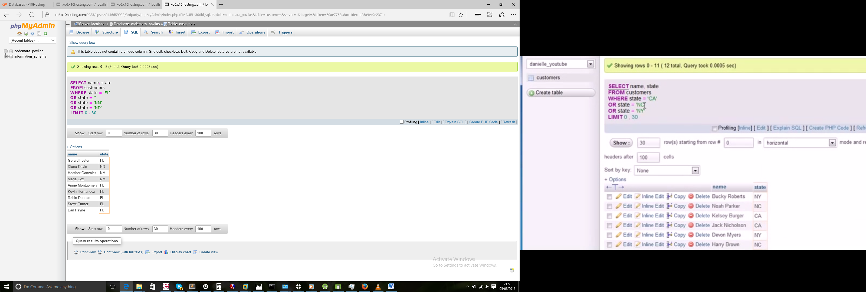

SELECT name,state FROM customers WHERE state IN('CA','NM','ND')

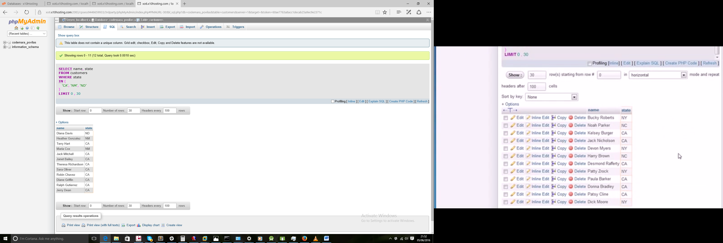

SELECT name,state FROM customers WHERE state IN('CA','NM','ND') ORDER BY state

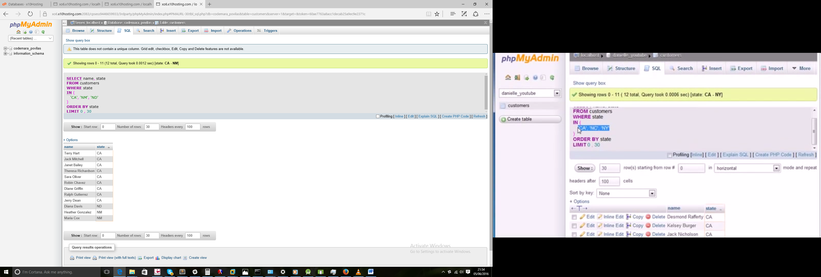

SELECT name,state FROM customers WHERE state NOT IN('CA','NM','ND') ORDER BY state

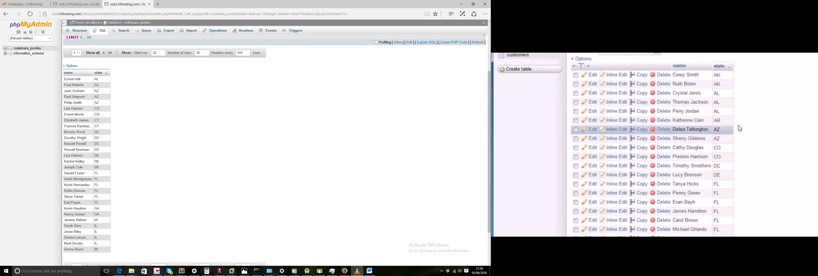

## 13 - How Search Engines Work

SELECT name FROM items WHERE name LIKE 'new%'

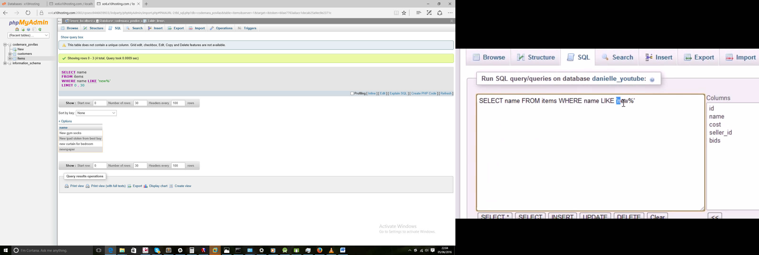

SELECT name FROM items WHERE name LIKE '%new%'

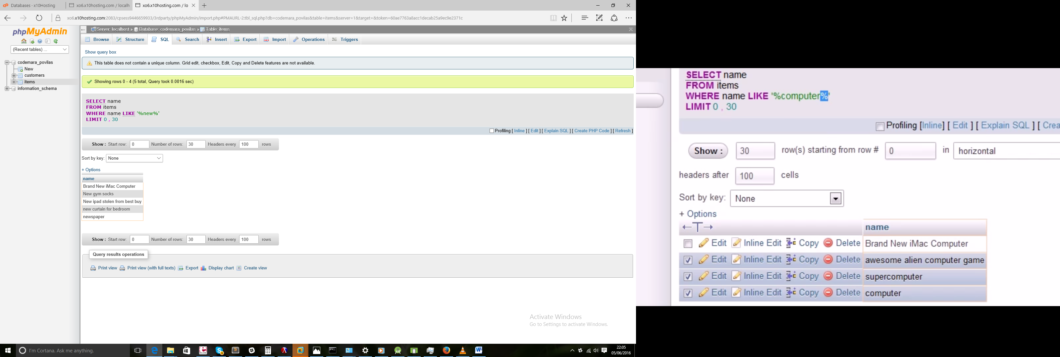

SELECT city FROM customers WHERE city LIKE 'h%d'

Start with h ends with d.

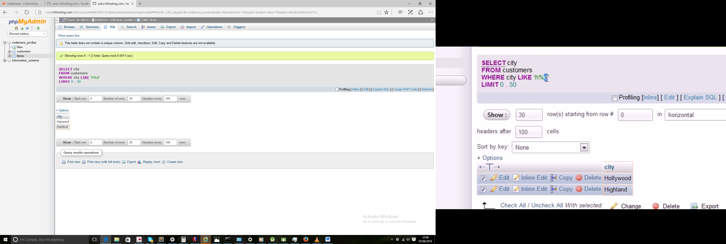

## 14 - More on Wildcards

SELECT name FROM items WHERE name LIKE '_ boxes of frogs'

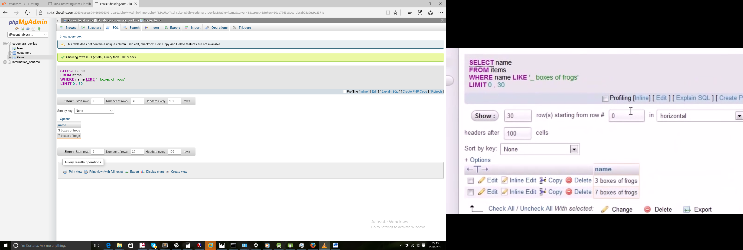

SELECT name FROM items WHERE name LIKE '% boxes of frogs'

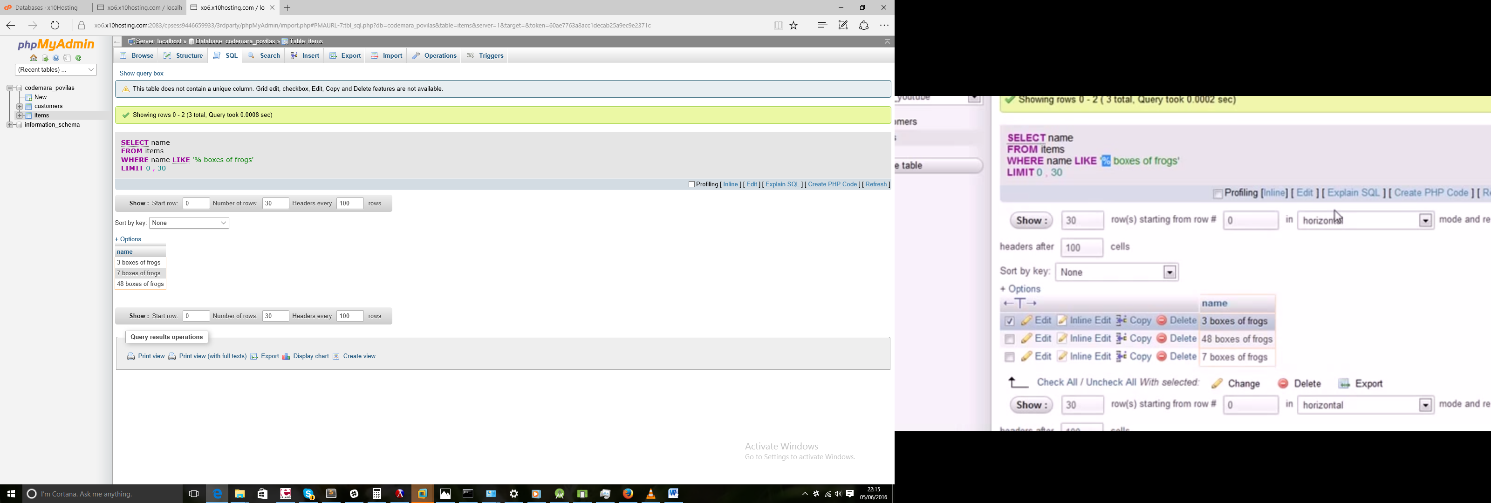

## 15 - Regular Expressions

SELECT name FROM items WHERE name REGEXP 'new'

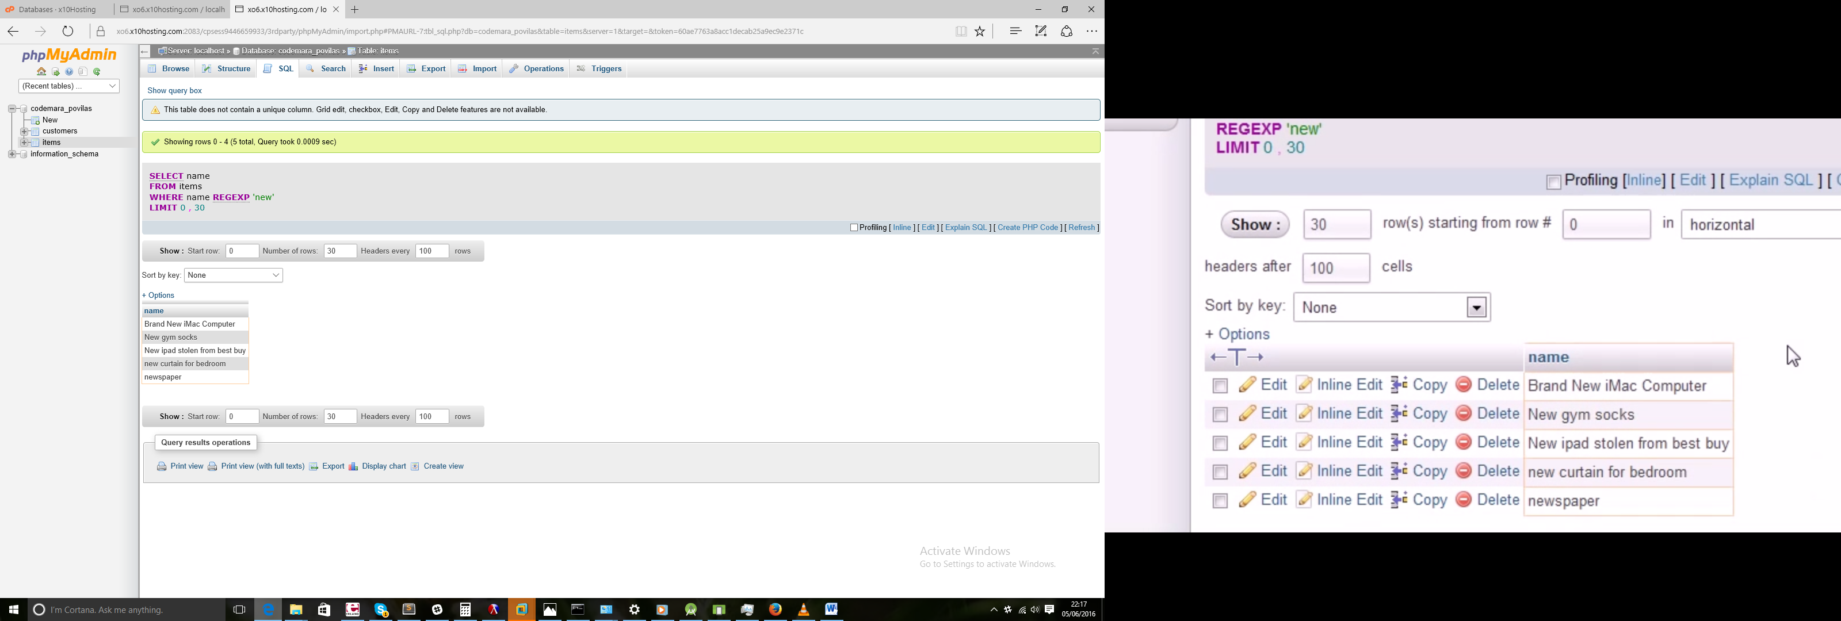

SELECT name FROM items WHERE name REGEXP '.boxes'

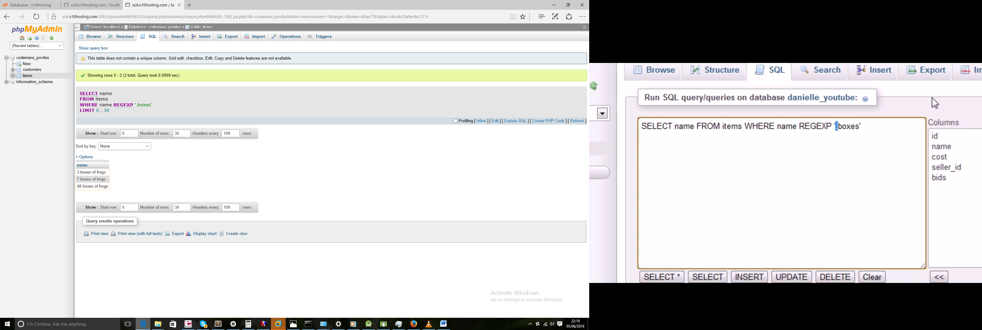

SELECT name FROM items WHERE name REGEXP 'gold|car'

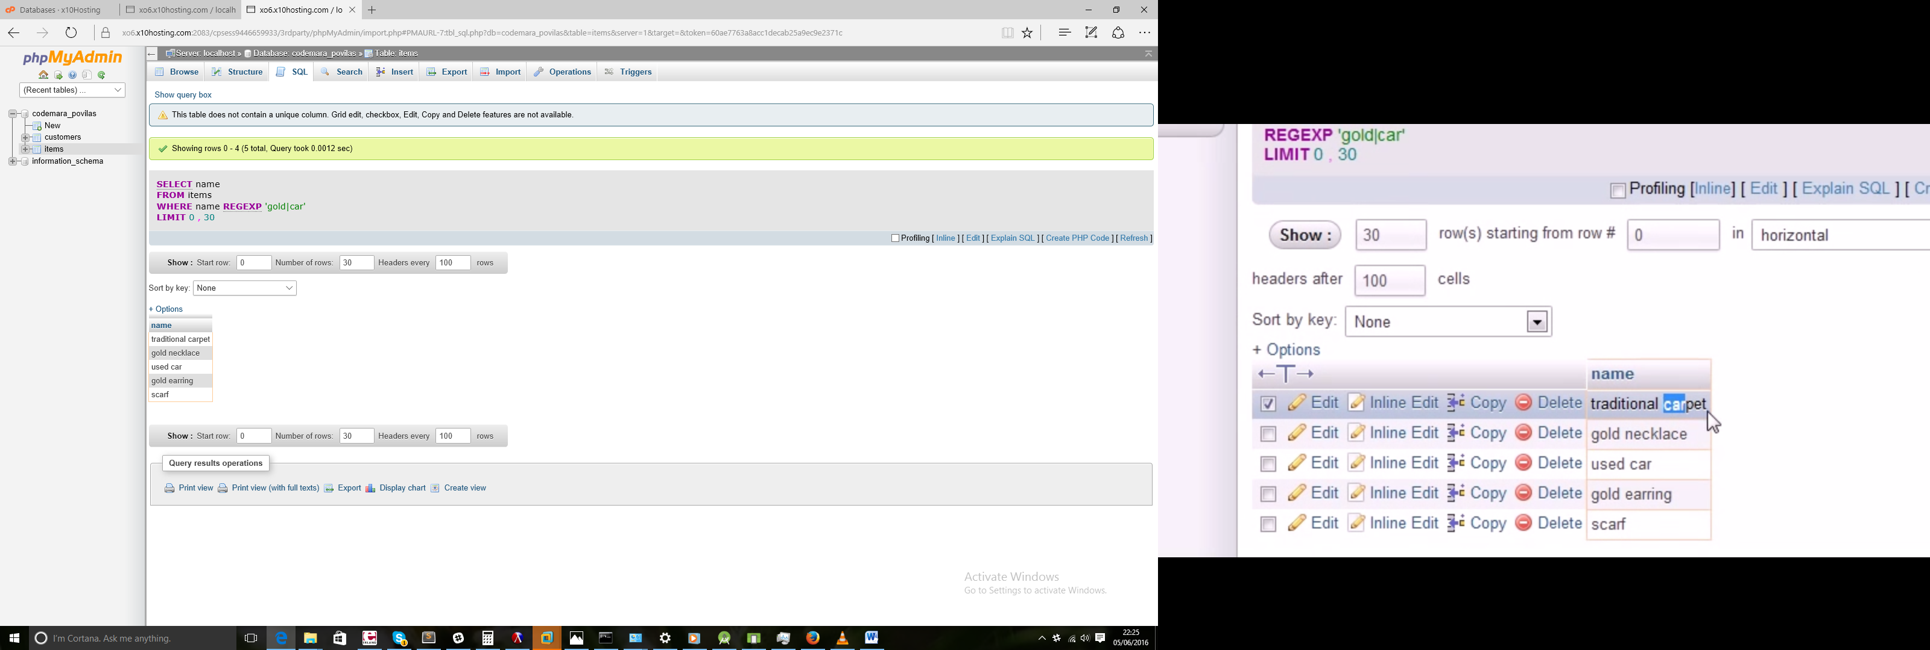

SELECT name FROM items WHERE name REGEXP '[12345] boxes of frogs'

Same thing as

SELECT name FROM items WHERE name REGEXP '[1-5] boxes of frogs'

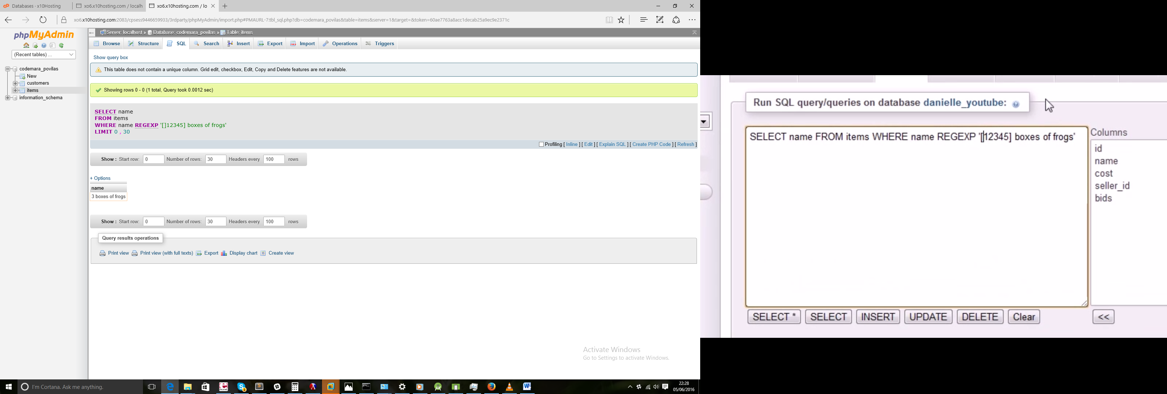

SELECT name FROM items WHERE name REGEXP '[^12345] boxes of frogs'

Search for anything besides 12345

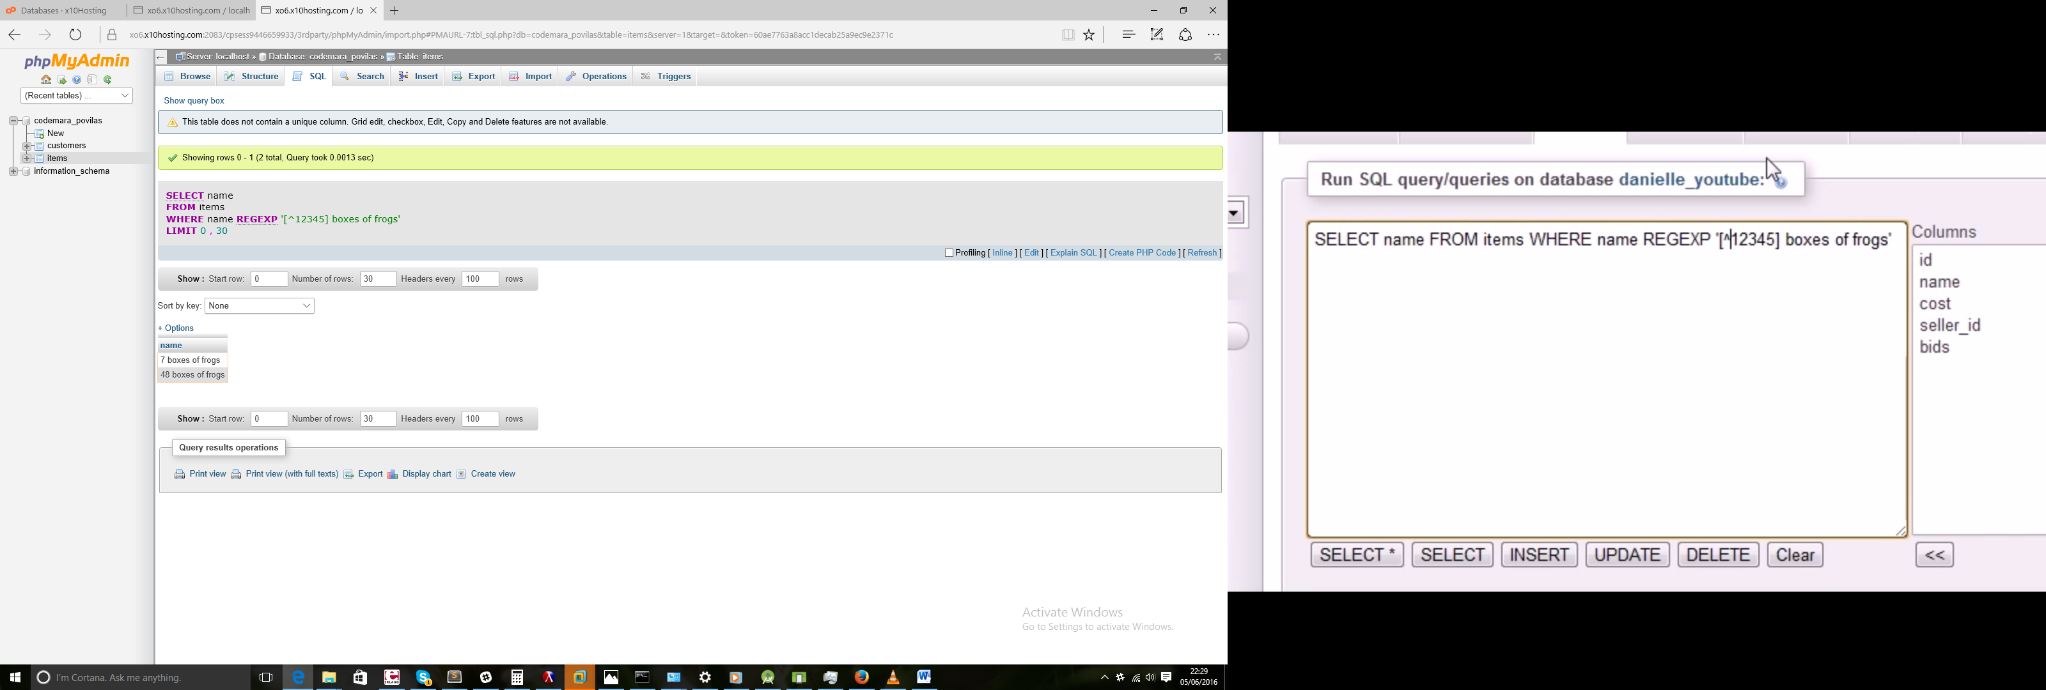

## 16 - Creating Custom Columns

SELECT CONCAT(city, ', ', state) FROM customers

Concat joins things together

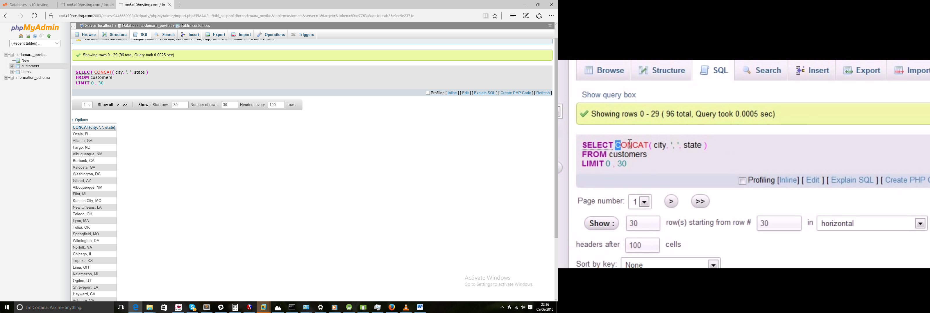

SELECT CONCAT(city, ', ', state) AS new_address FROM customers

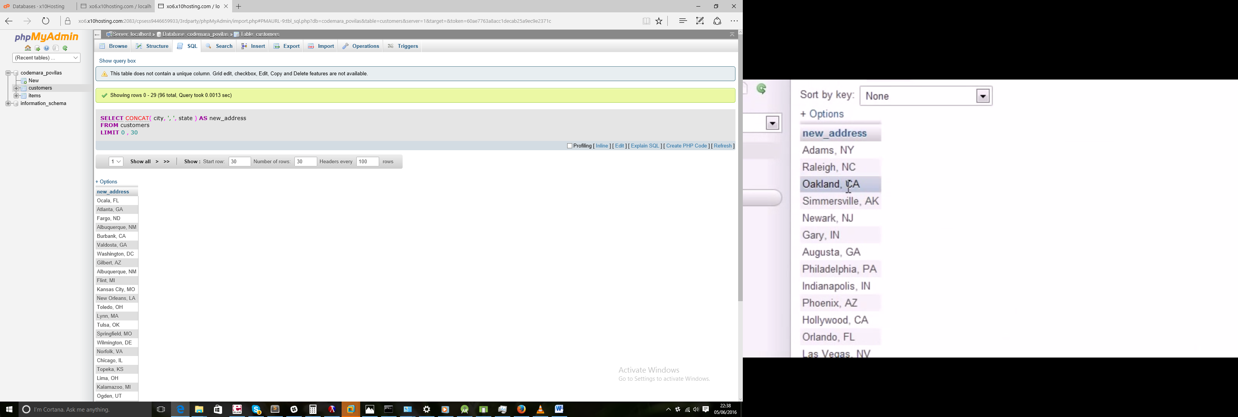

SELECT name,cost FROM items

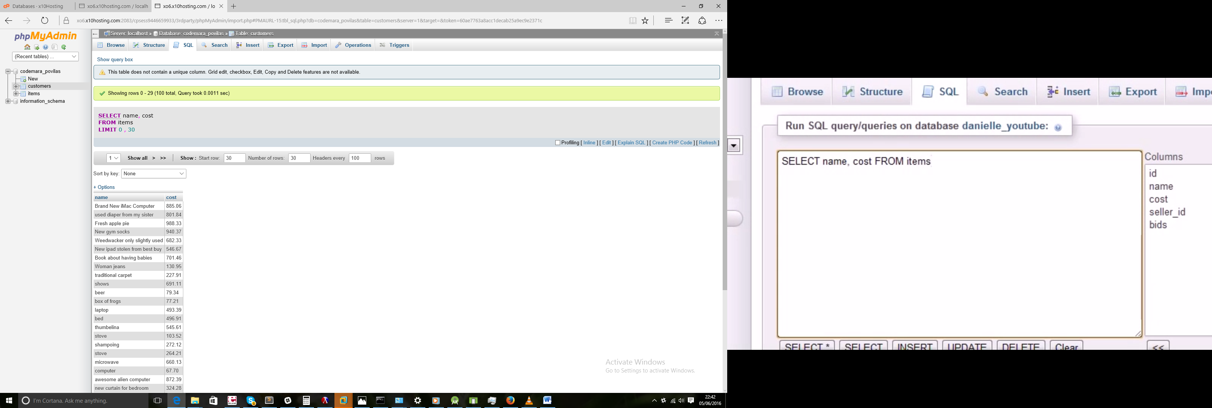

SELECT name,cost, cost -1 FROM items

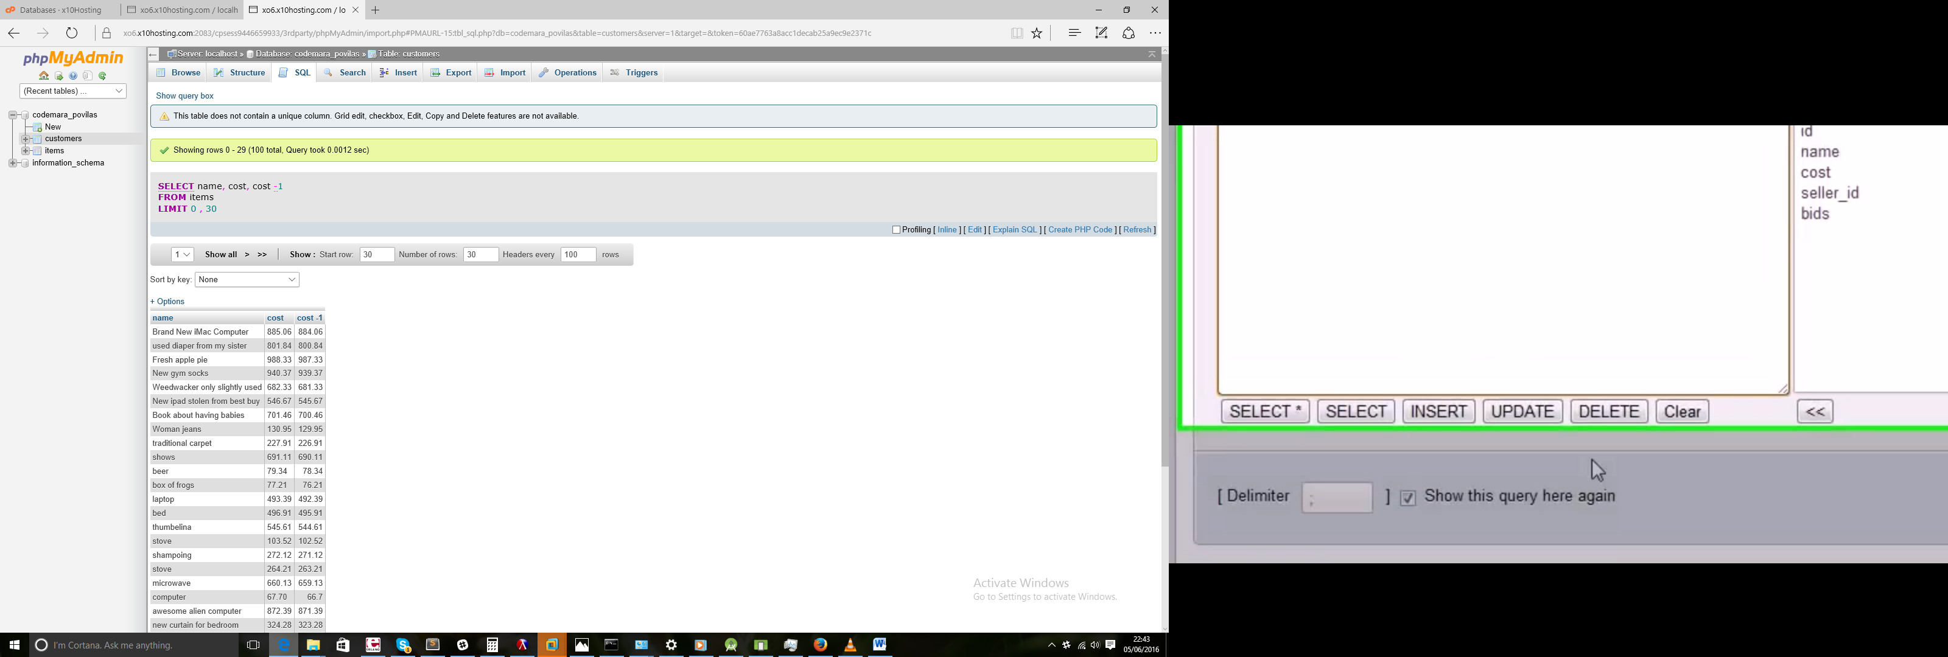

SELECT name,cost, cost -1 AS sale_proce FROM items

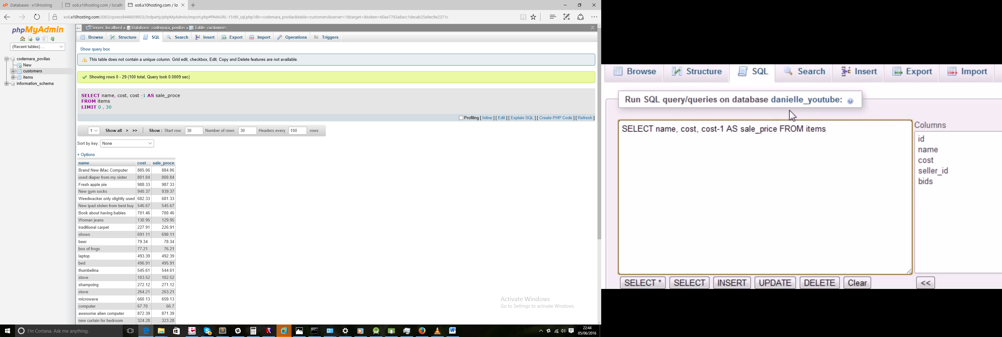

## 17 – Functions

SELECT name, UPPER(name) FROM customers

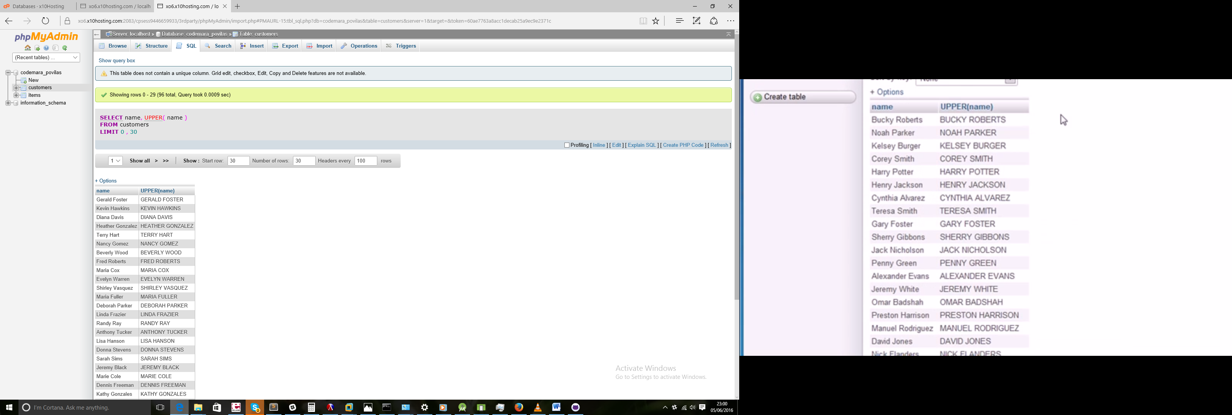

SELECT cost, SQRT(cost) FROM items

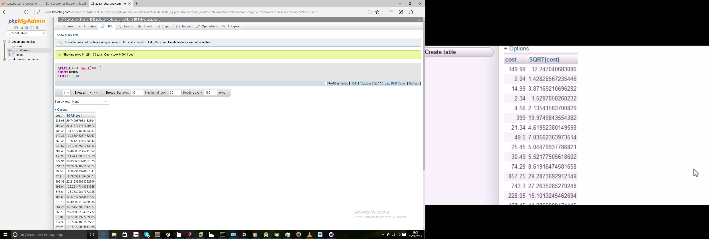

SELECT AVG(cost) FROM items

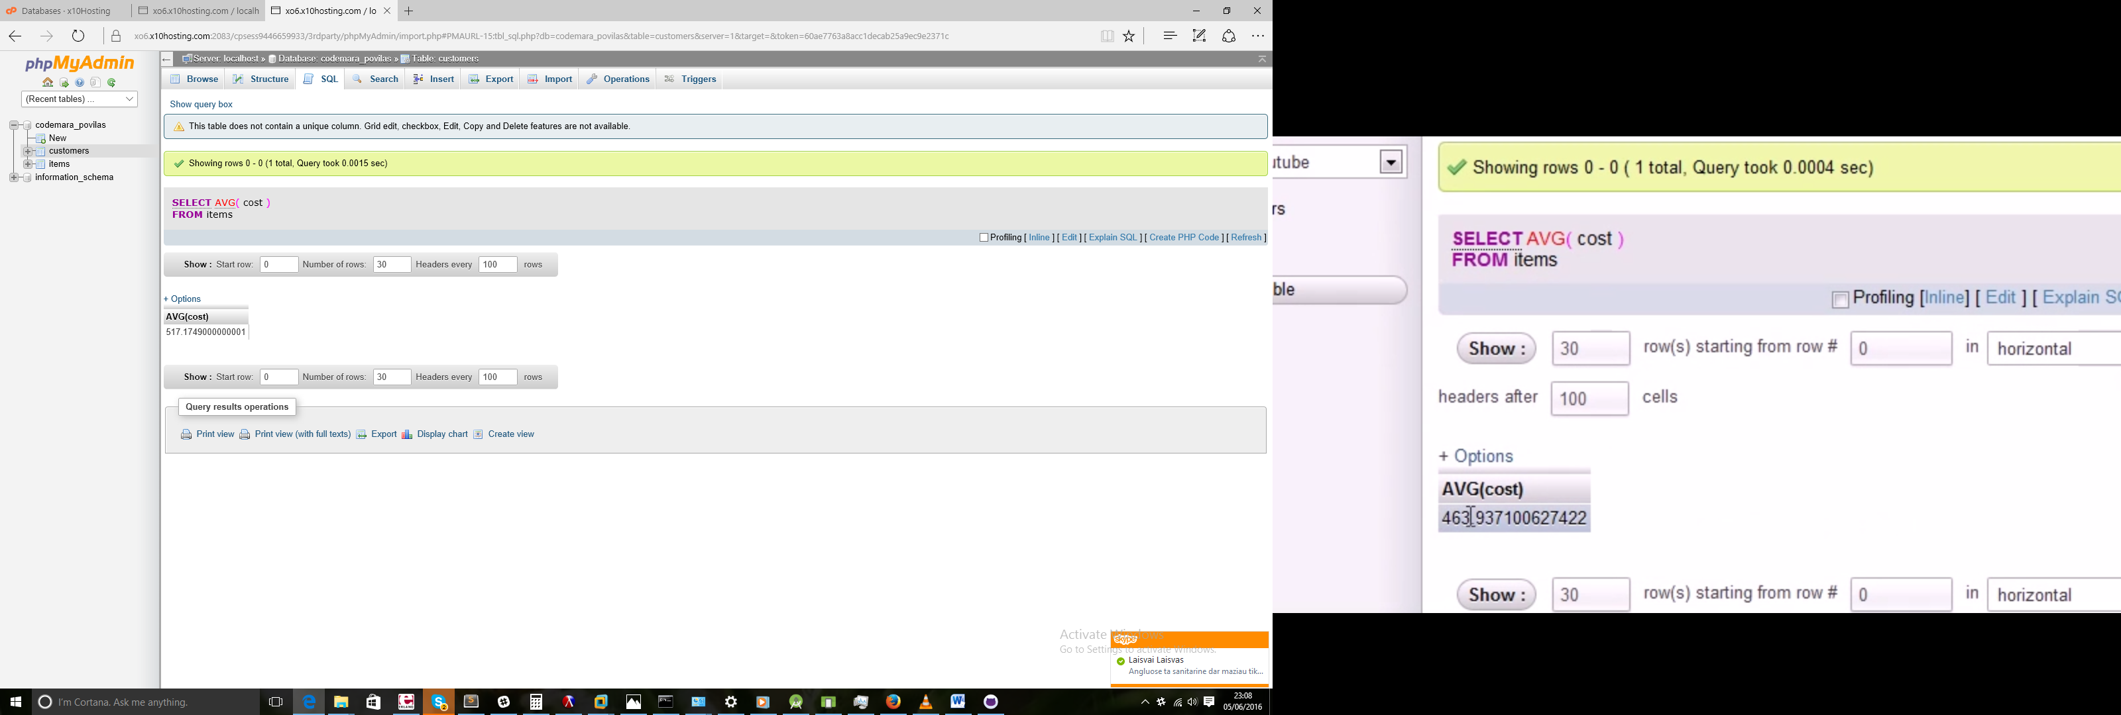

SELECT SUM(bids) FROM items

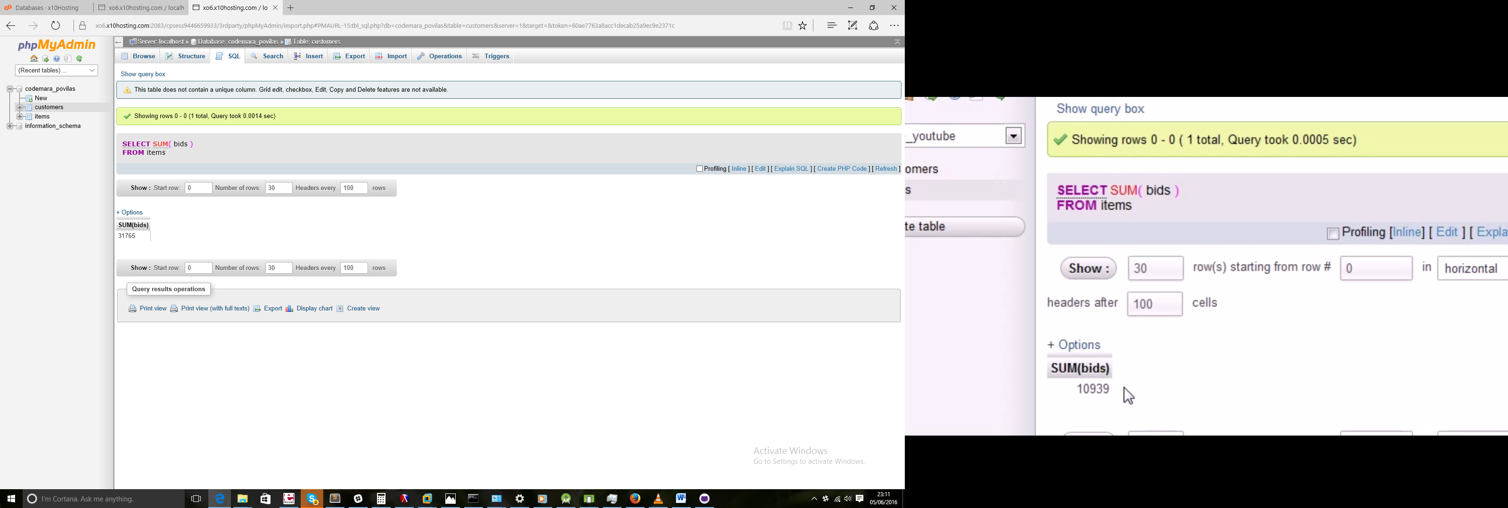

## 18 - More on Aggregate Functions

SELECT COUNT(name) FROM items WHERE seller_id=6

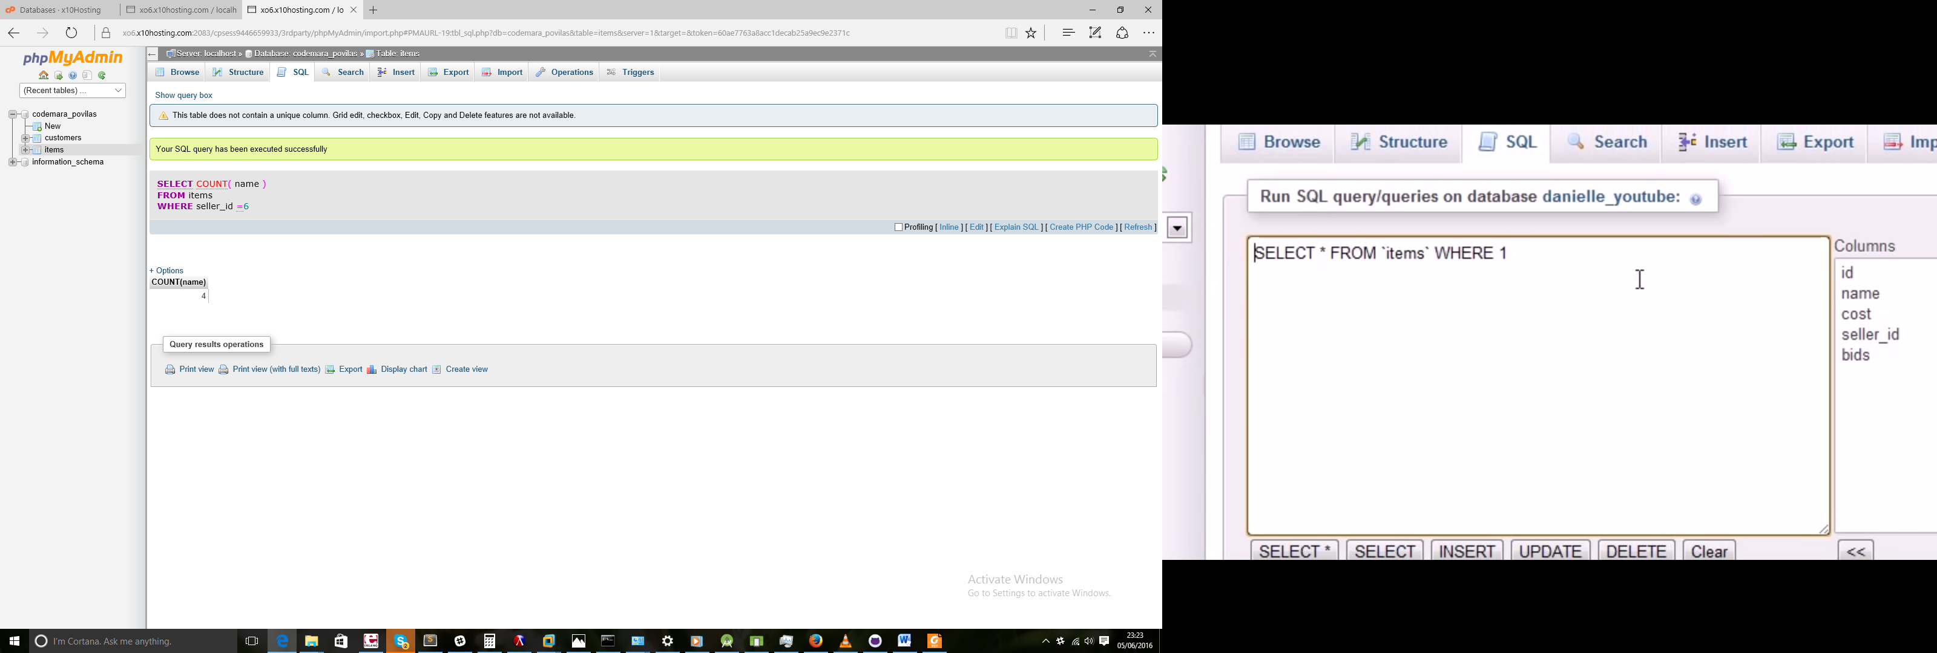

SELECT AVG(cost) FROM items WHERE seller_id=6

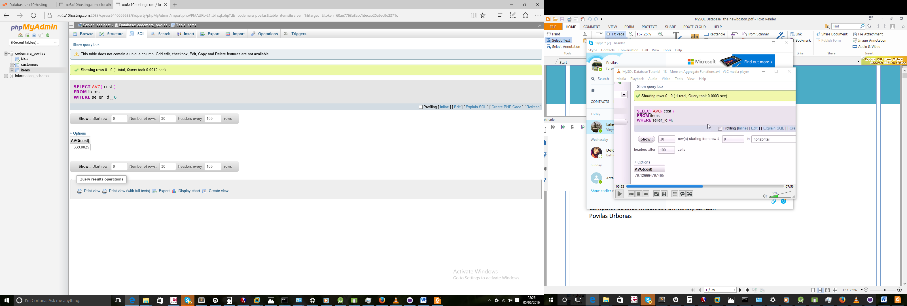

SELECT COUNT(*) AS item_count,

MAX(cost) AS max,

AVG(cost) AS avg

FROM items WHERE seller_id=12;

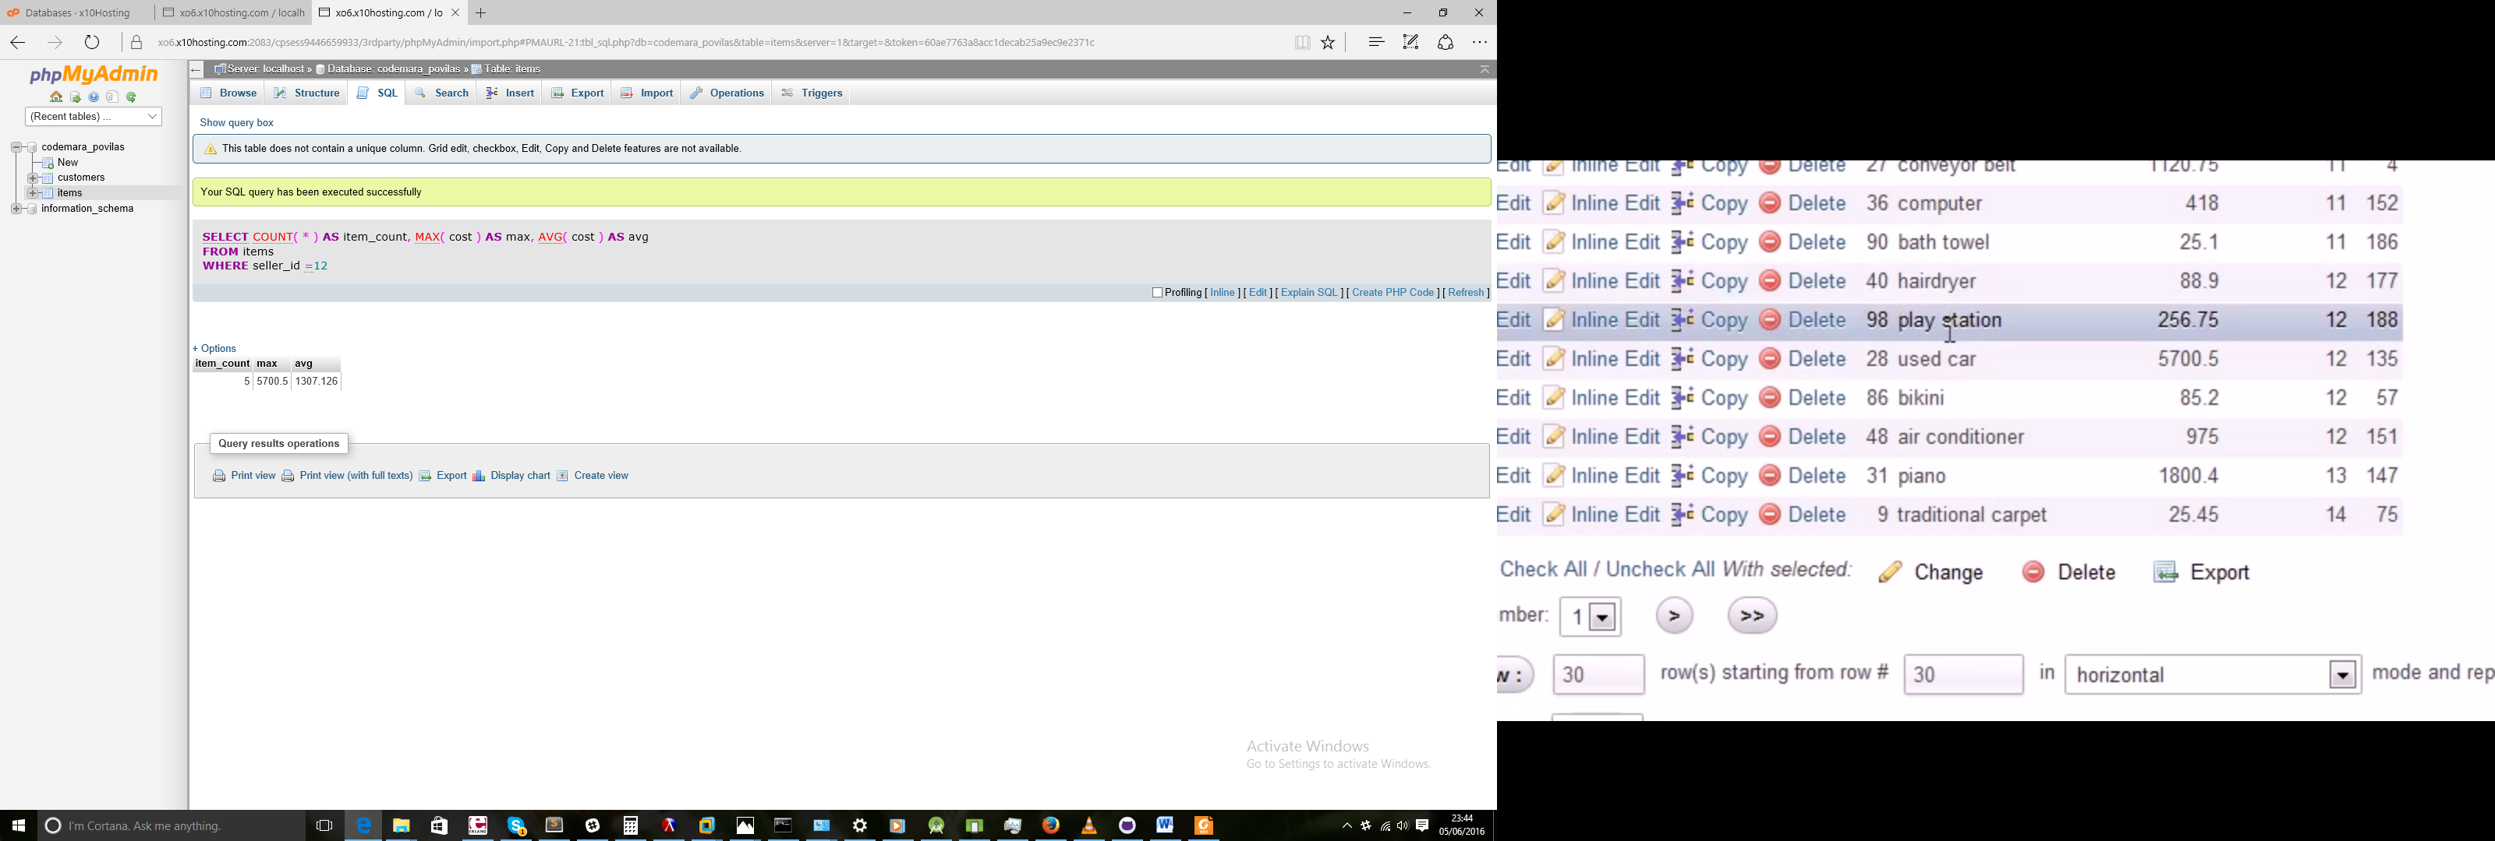

## 19 - GROUP BY

SELECT seller_id, COUNT(*) AS item_count FROM items WHERE seller_id=1

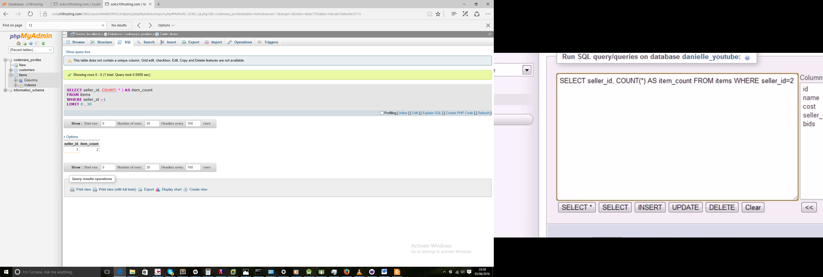

SELECT seller_id, COUNT(*) AS item_count FROM items GROUP BY seller_id

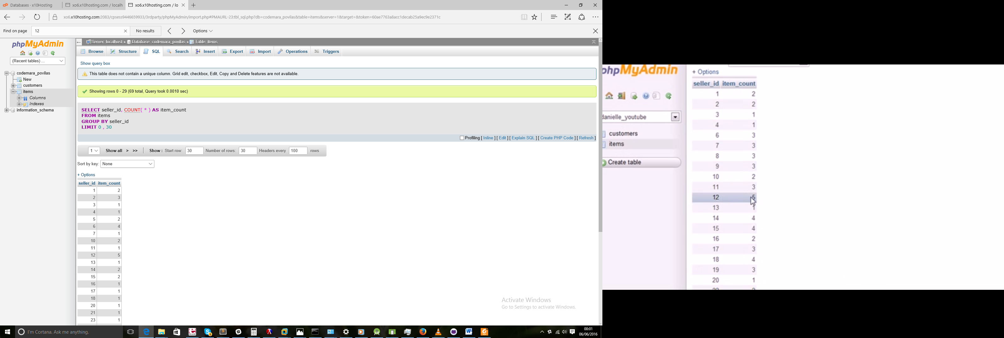

SELECT seller_id, COUNT(*) AS item_count FROM items GROUP BY seller_id Having COUNT(*)>=3

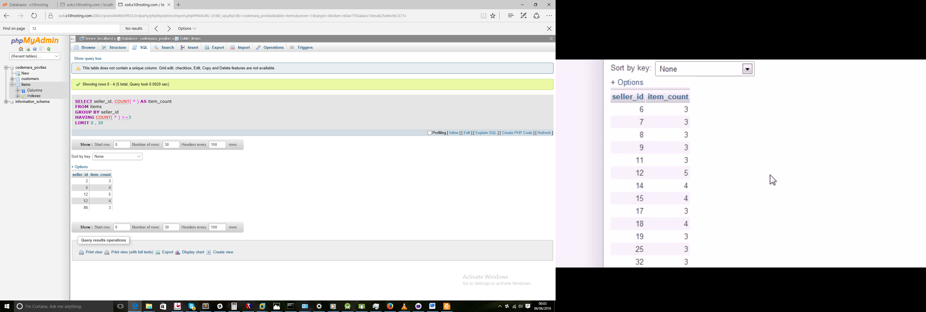

SELECT seller_id, COUNT(*) AS item_count FROM items GROUP BY seller_id Having COUNT(*)>=3 ORDER BY

item_count DESC

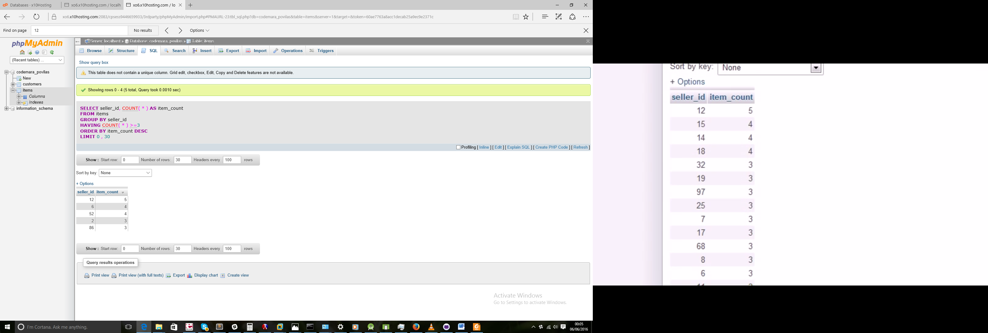

## 20 – Subqueries

SELECT AVG(cost) FROM items

| **AVG(cost)** |  |
| --- | --- |
| 517.1749000000001 |  |

*SELECT name, cost FROM items WHERE cost>(517) ORDER BY cost DESC*

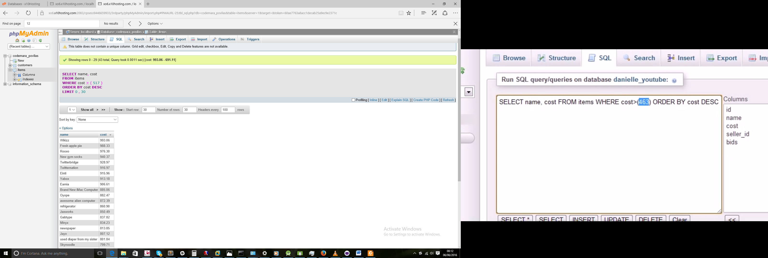

SELECT name, cost FROM items WHERE cost>(

SELECT AVG(cost) FROM items

)ORDER BY cost DESC

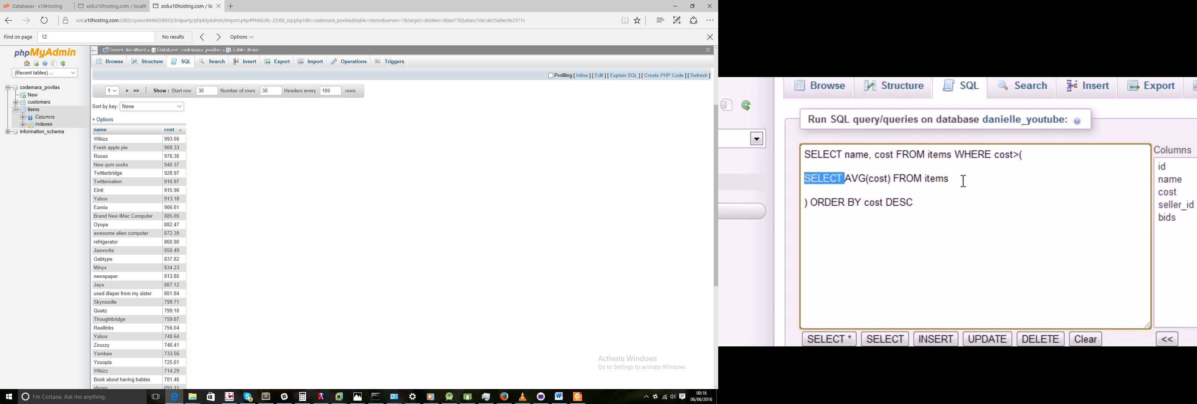

## 21 - Another Subquery Example

SELECT seller_id FROM items WHERE name LIKE '%boxes of frogs'

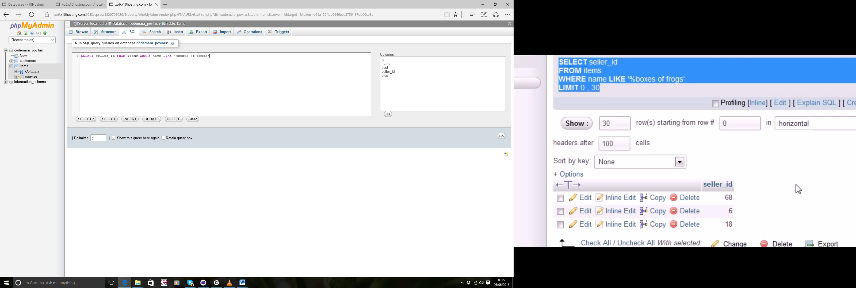

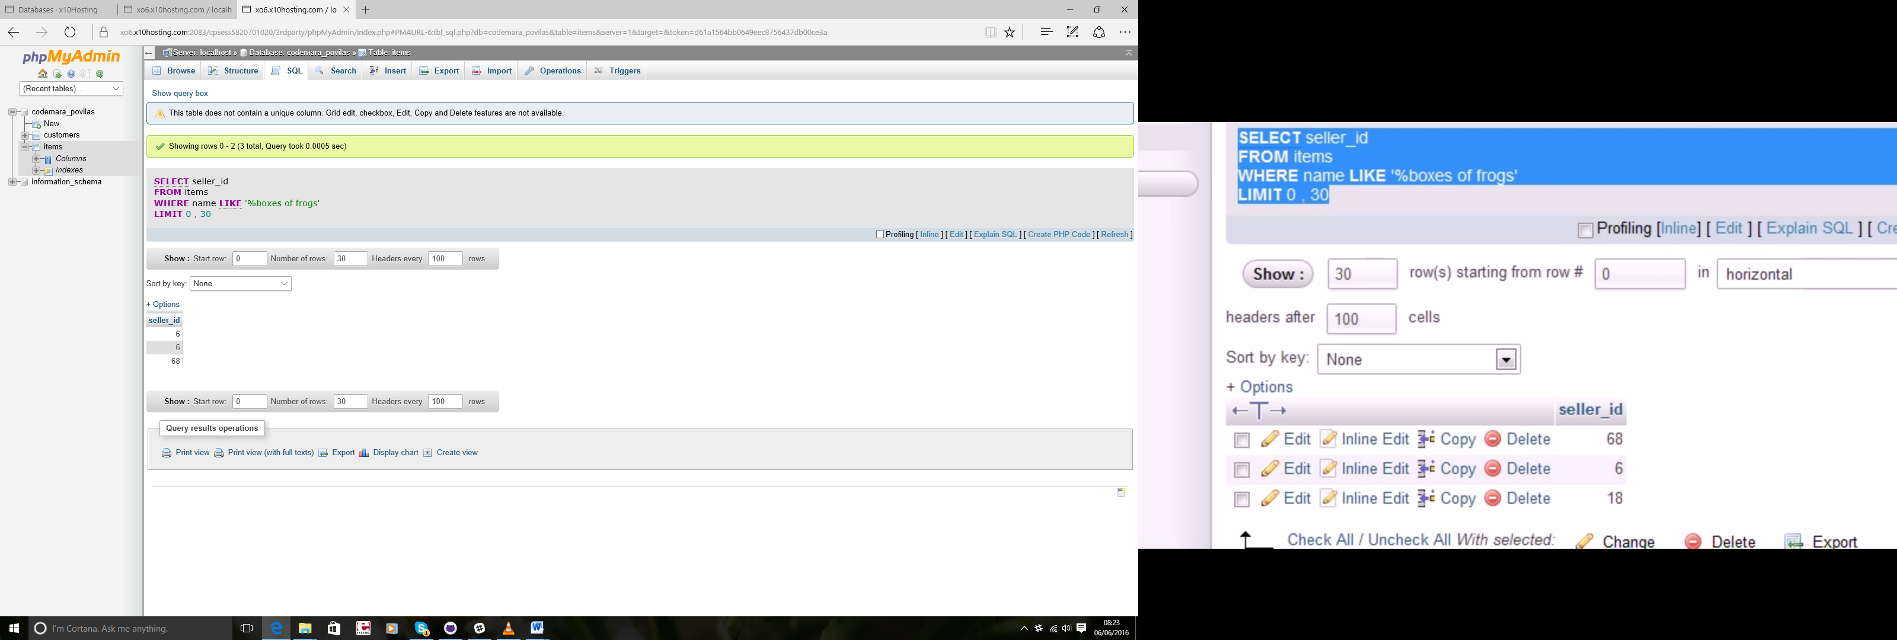

SELECT name , MIN(cost) FROM items WHERE name LIKE '%boxes of frogs'

AND seller_id IN(68,6 ,6)

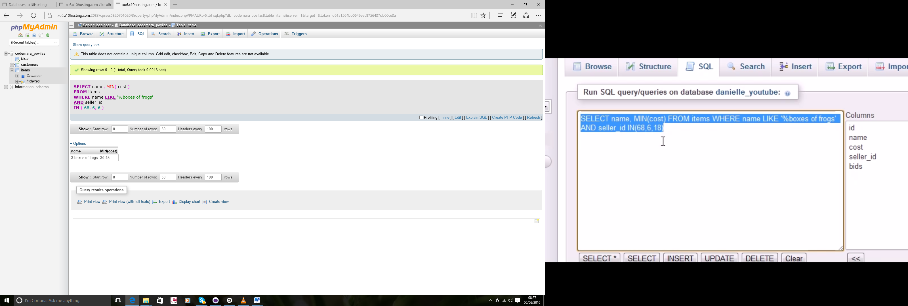

SELECT name , MIN(cost) FROM items WHERE name LIKE '%boxes of frogs'

AND seller_id IN(

SELECT seller_id FROM items WHERE name LIKE '%boxes of frogs'

)

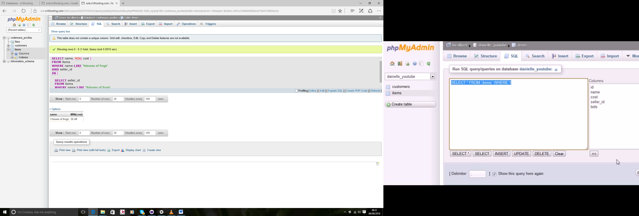

## 22 - How to Join Tables

SELECT customers.id, customers.name,items.name, items.cost

FROM customers,items

WHERE customers.id=seller_id

ORder by customers.id

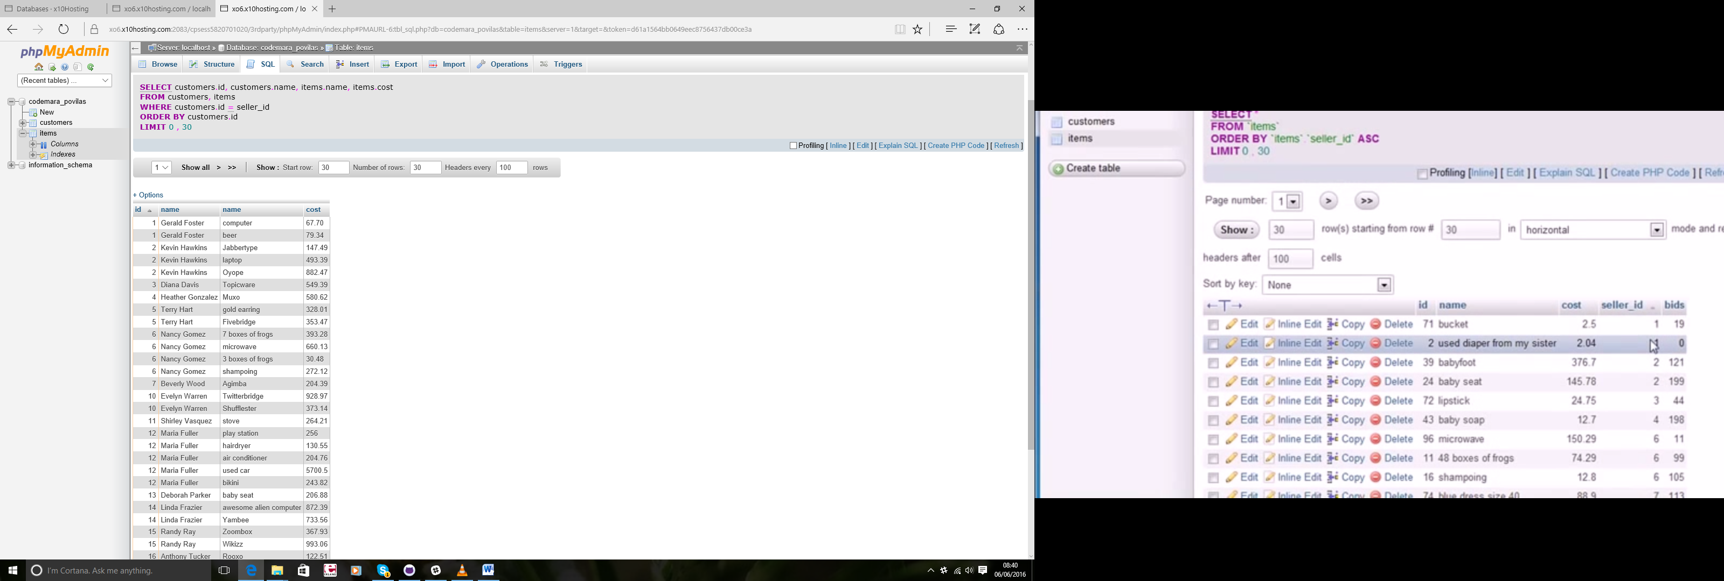

## 23 - Outer Joins

SELECT i.seller_id, i.name, c.id

FROM customers AS c, items AS i

WHERE i.seller_id=c.id

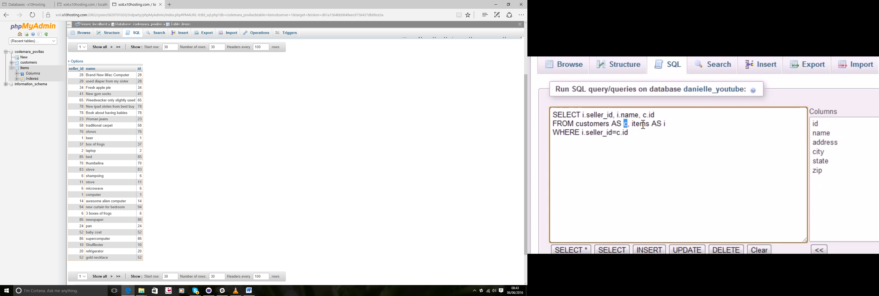

SELECT customers.name, items.name FROM customers, items WHERE

customers.id=seller_id

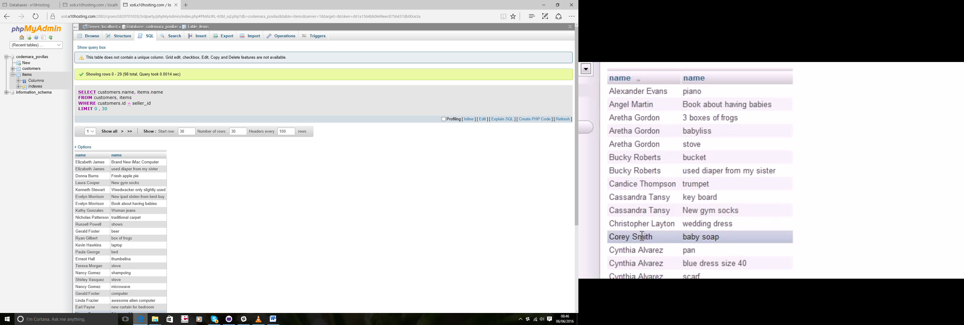

SELECT customers.name, items.name FROM customers LEFT OUTER JOIN

items ON customers.id=seller_id

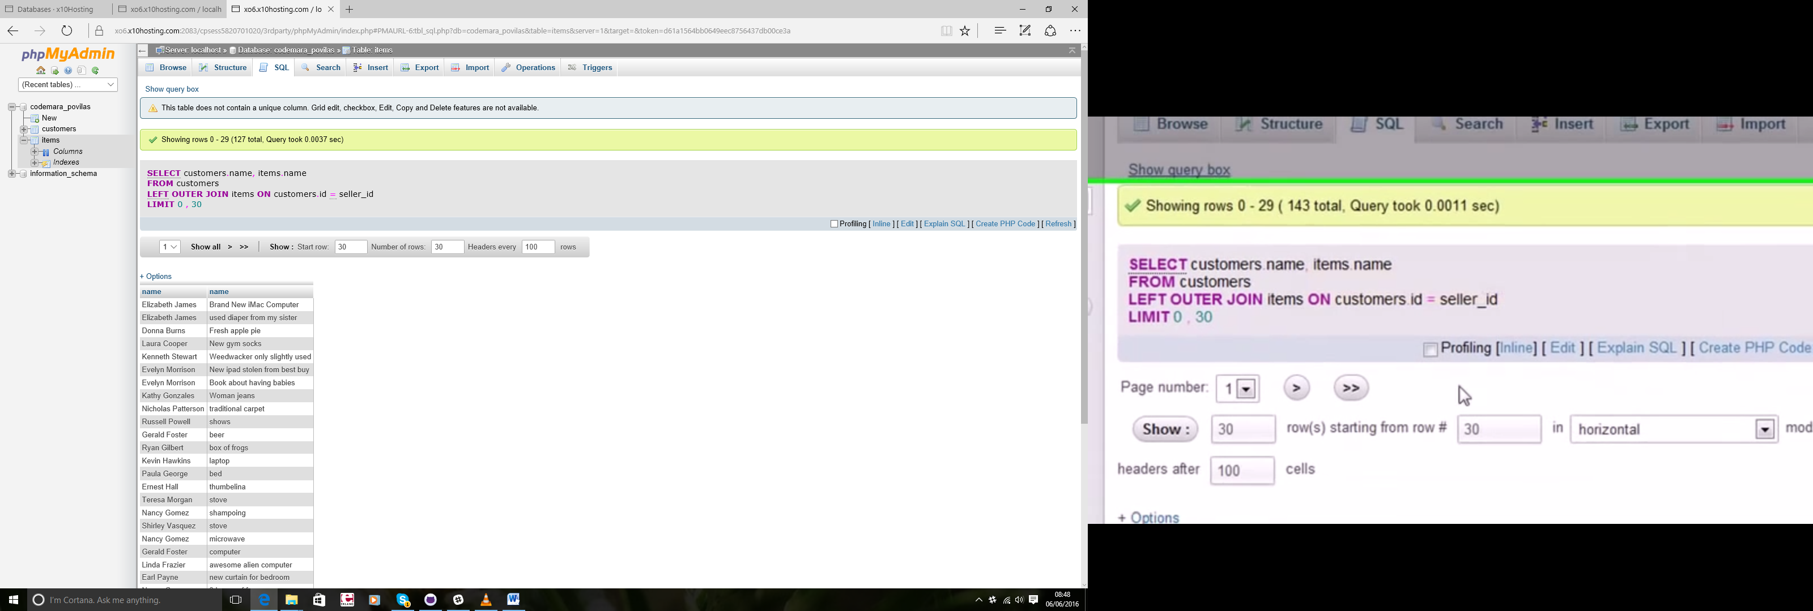

## 24 – UNION

SELECT name,cost, bids FROM items WHERE bids>190

UNION

SELECT name,cost, bids FROM items WHERE bids>1000

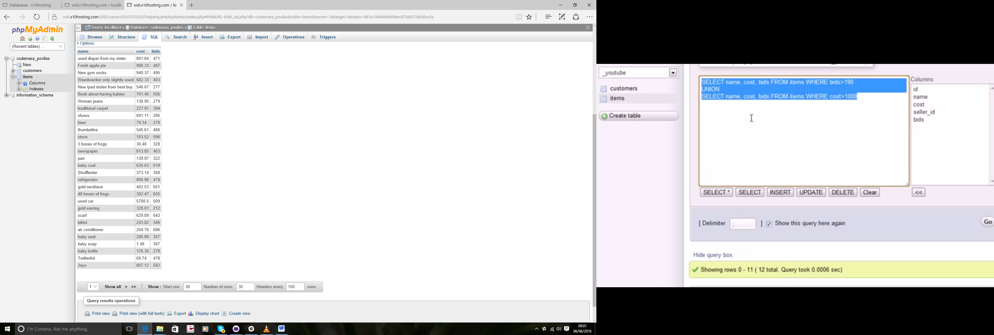

## 25 - Full-Text Searching

SELECT name, cost FROM items WHERE Match(name) Against('baby')

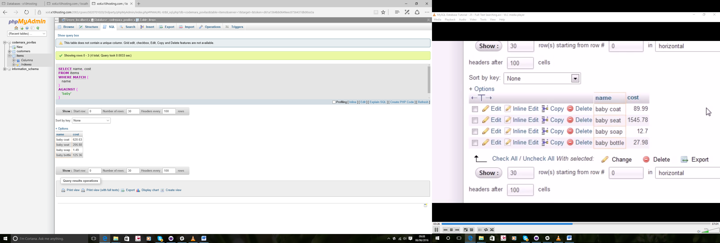

SELECT name, cost FROM items WHERE Match(name) Against('+baby -coat'

IN BOOLEAN MODE)

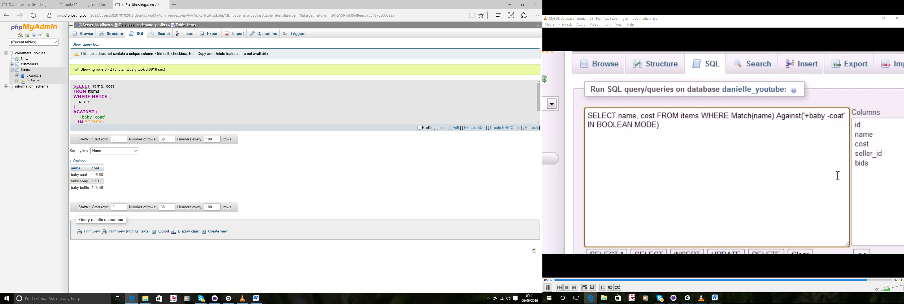

## 26 - INSERT INTO

INSERT INTO items VALUES('101','bacon strips','9.95','1','0')

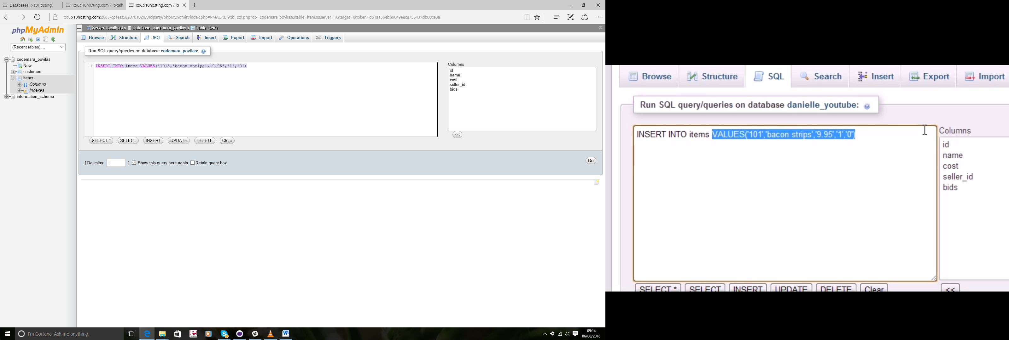

INSERT INTO items (id, name,cost,seller_id,bids) VALUES('102',

'fisn and chips','7.99','1','0')

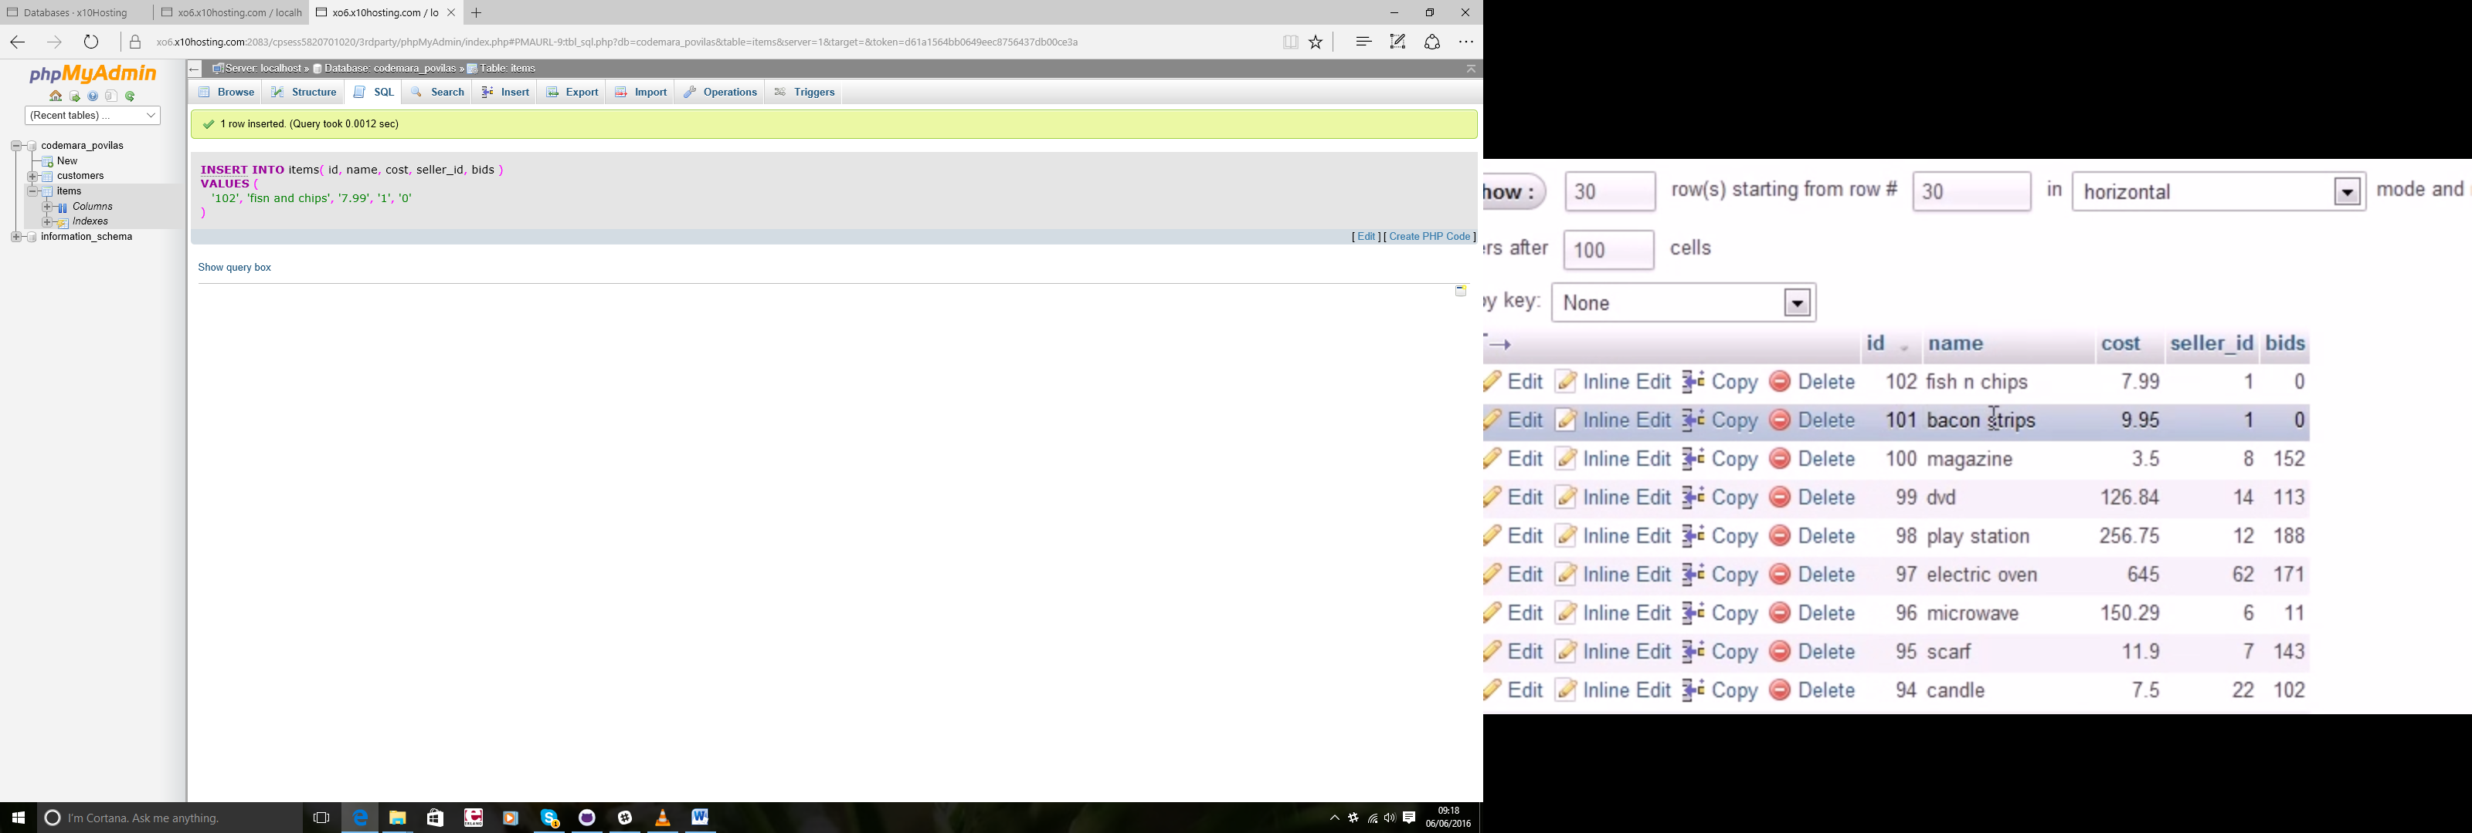

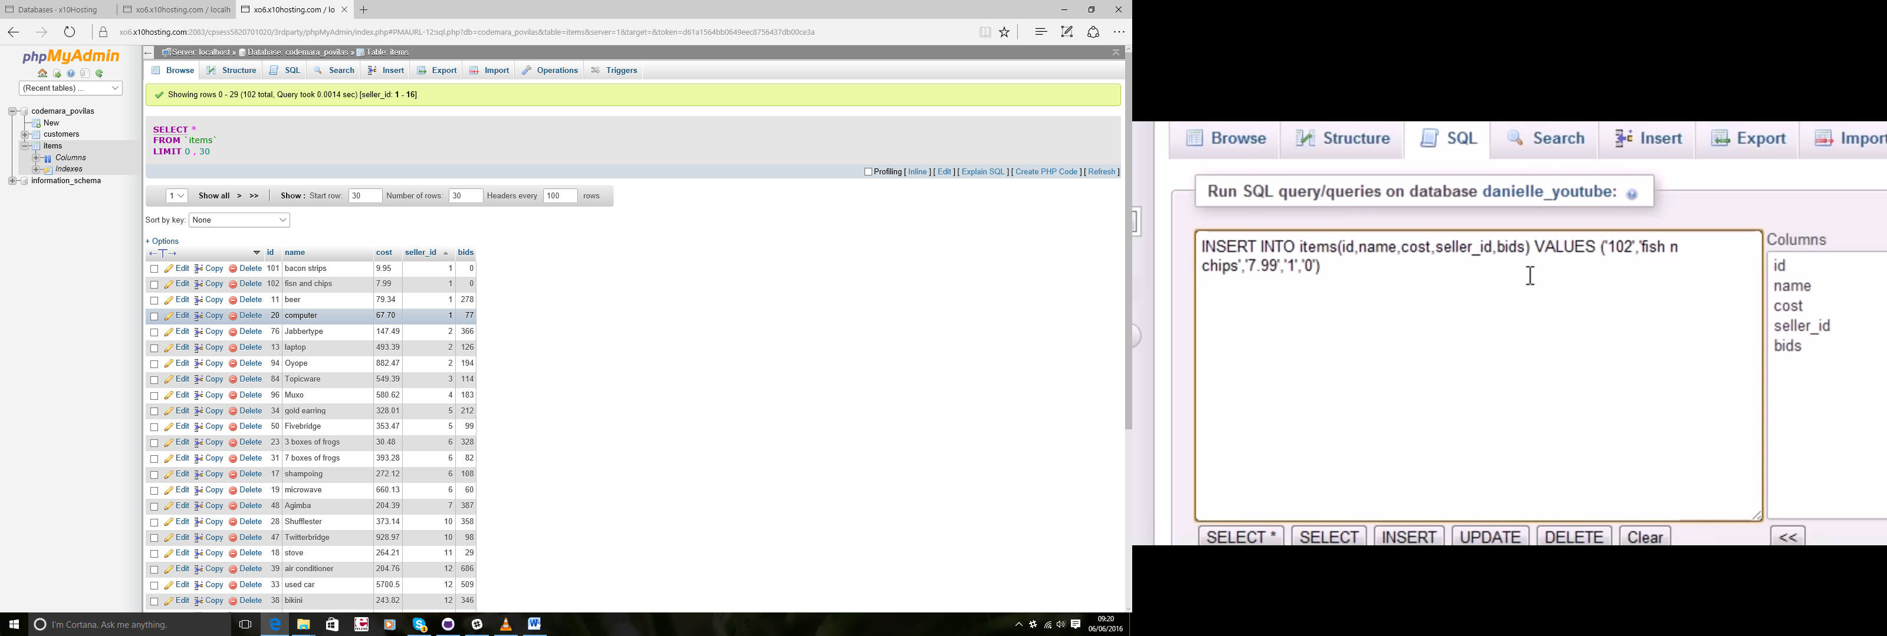

INSERT INTO items (id, cost,name) VALUES

('104',8.88,'baby potatos)

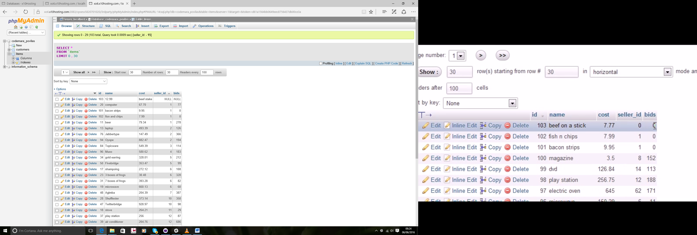

INSERT INTO items (id, cost,name) VALUES

('104',8.88,'baby potatos')

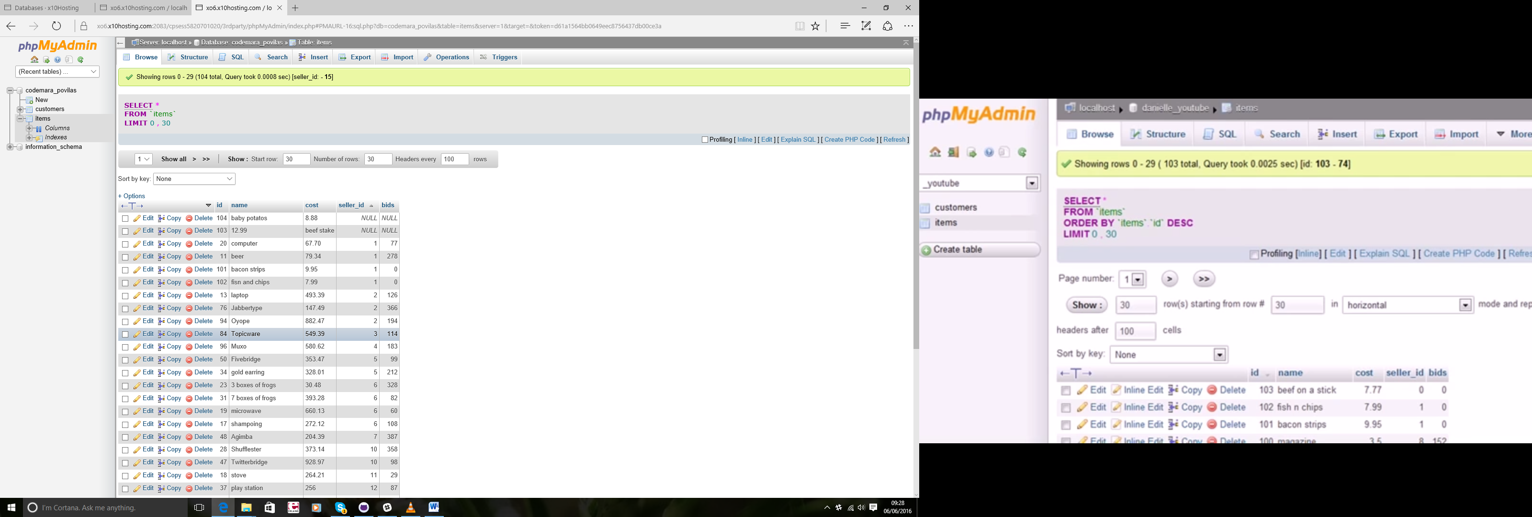

## 27 - How to Insert Multiple Rows

INSERT INTO items(id,name,cost,seller_id,bids)VALUES

('105','beef chops','7.69','1','0'),

('106','jelly pockets','4.50','1','0'),

('107','sack of ham','9.95','1','0')

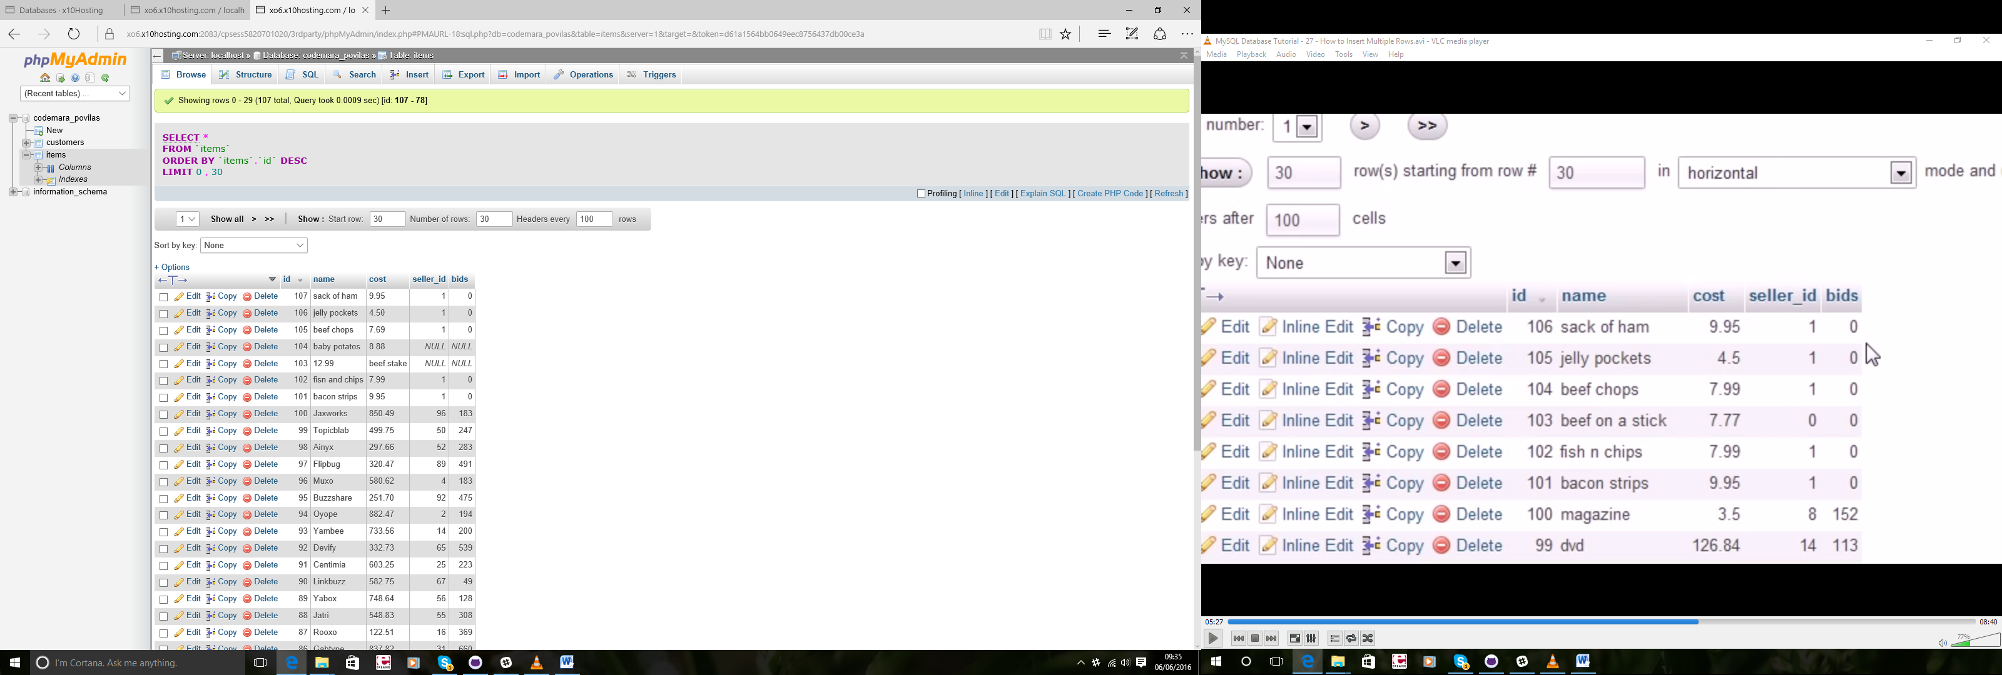

INSERT INTO items(id,name,cost,seller_id,bids) SELECT id,name,cost,seller_id,bids FROM faketable

## 28 - UPDATE & DELETE

UPDATE items SET name='puddinghammock' WHERE id=103

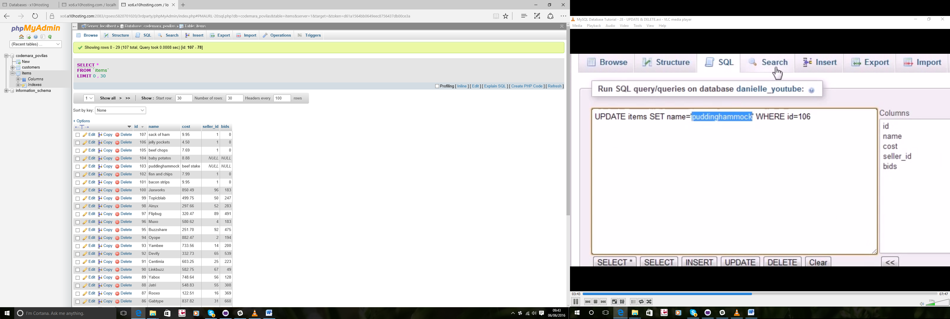

UPDATE items SET name='chicken paste',bids=66 WHERE id=104

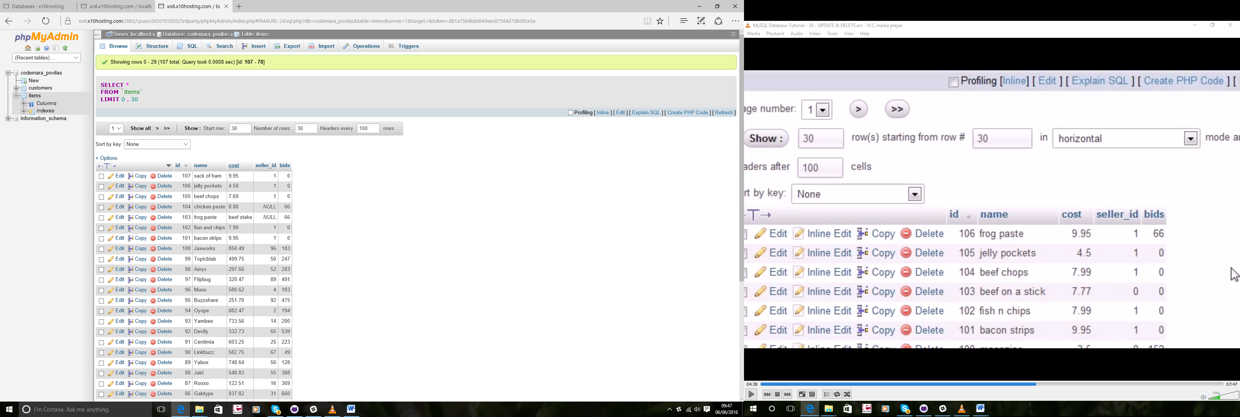

DELETE FROM items WHERE id=106

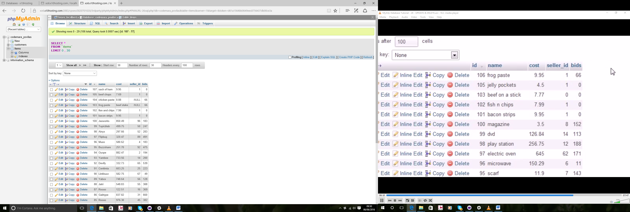

## 29 - CREATE TABLE

CREATE TABLE users(

id int,

username varchar(30),

password varchar(20),

PRIMARY KEY(id)

)

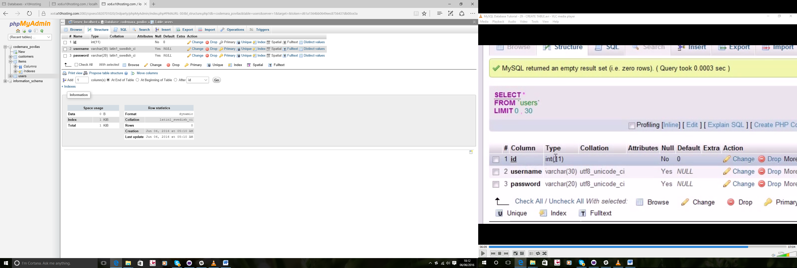

## 30 - NOT NULL & AUTO INCREMENT

username varchar(30) NOT NULL

id int NOT NULL AUTO_INCREMENT

automatically add 1 to the last id

CREATE TABLE bacon(

id int NOT NULL AUTO_INCREMENT,

username varchar(30) NOT NULL,

password varchar(20) NOT NULL,

PRIMARY KEY(id)

)

)

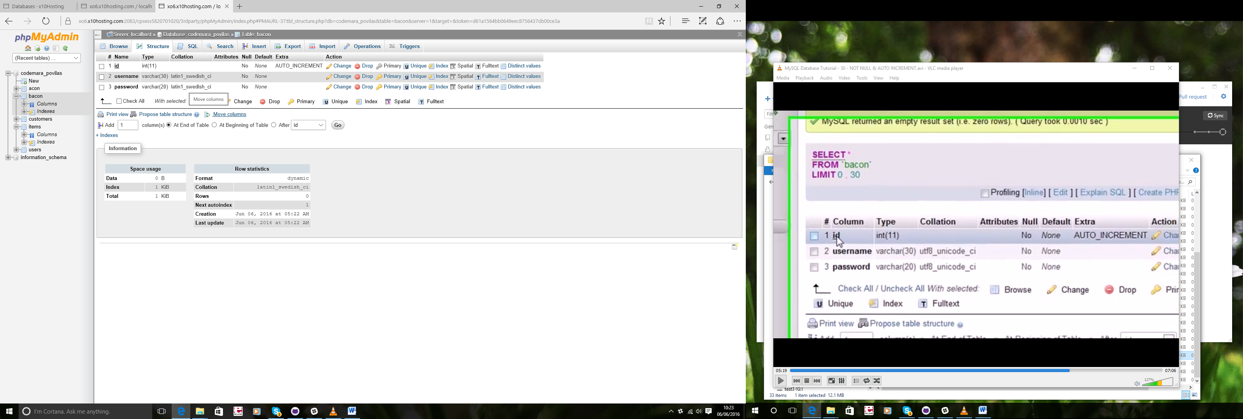

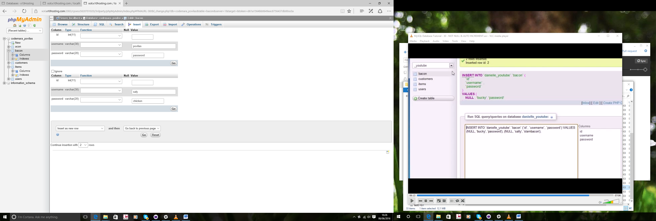

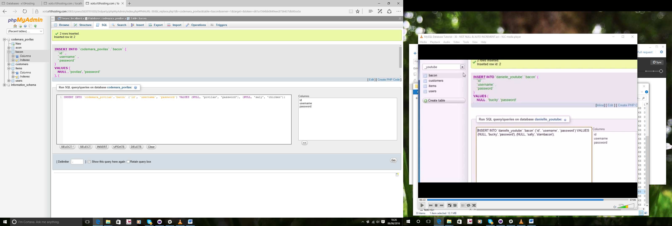

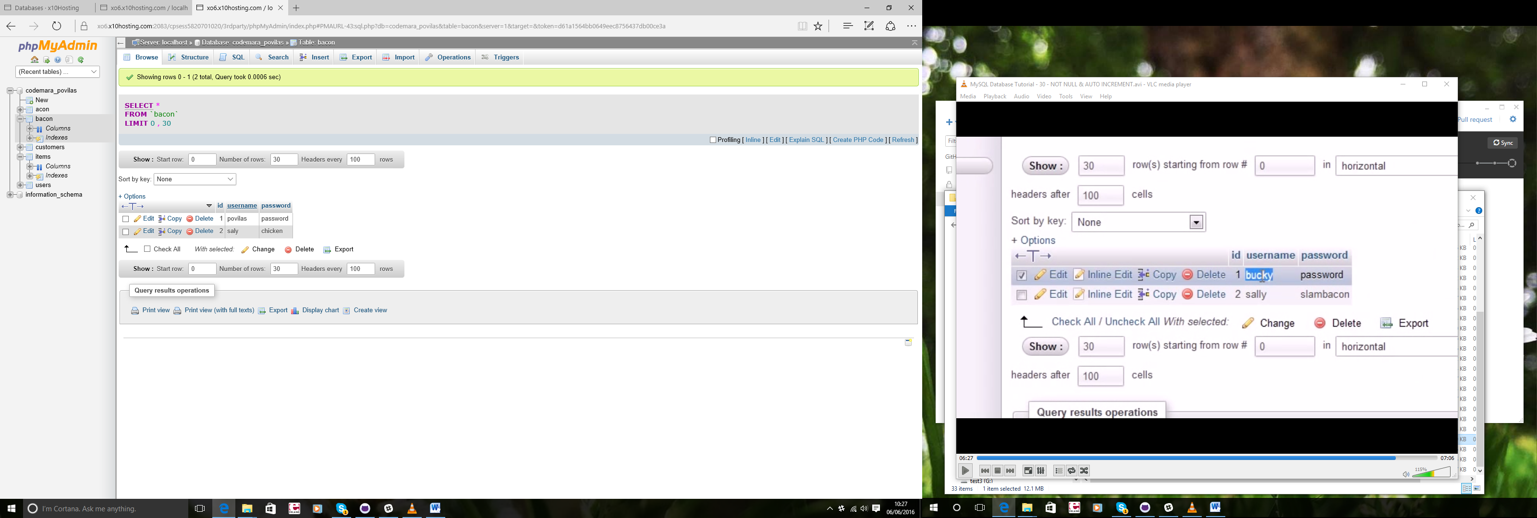

## 31 - ALTER DROP RENAME TABLE

ALTER TABLE bacon ADD samplecolumn varchar(10)

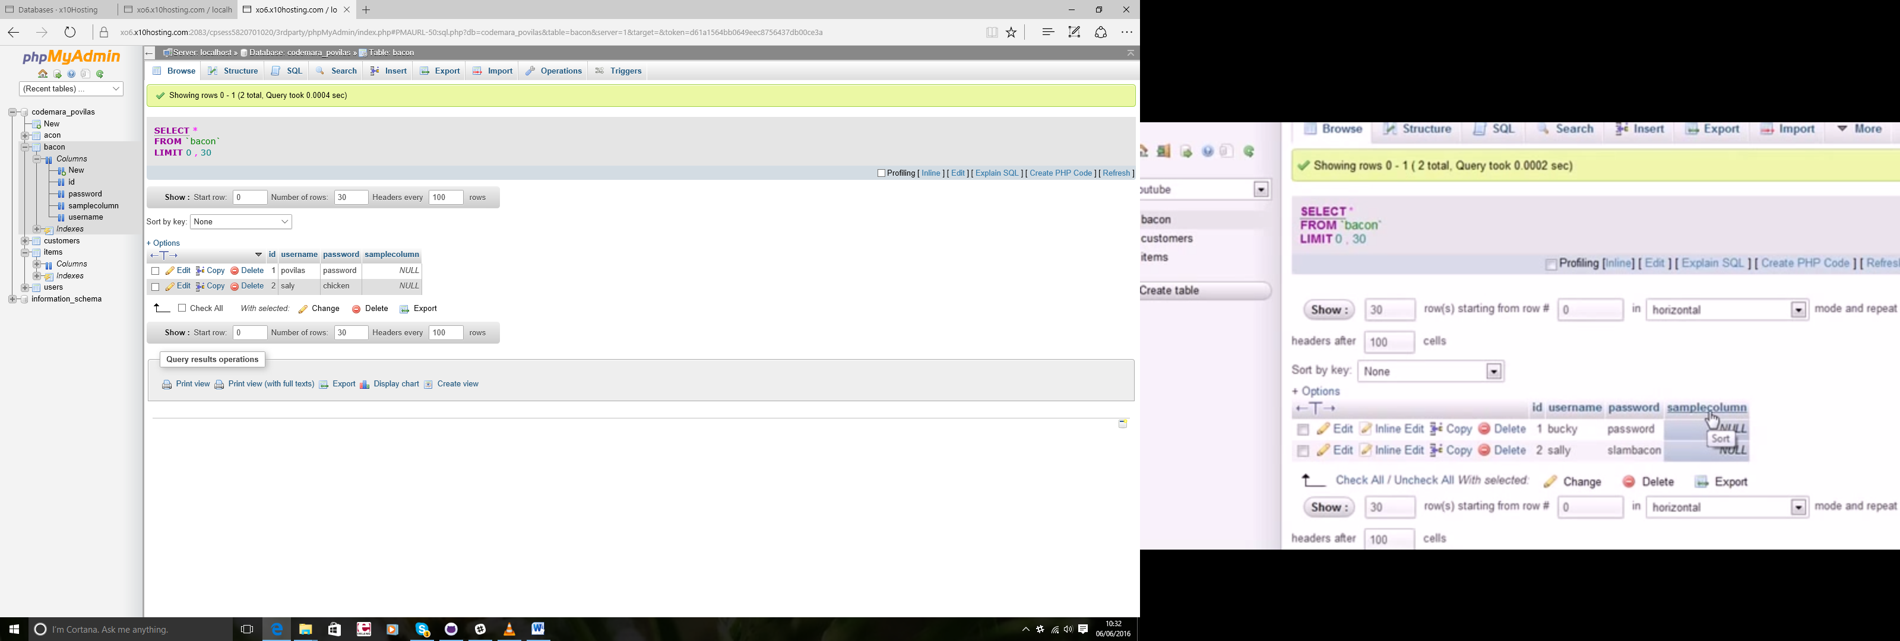

ALTER TABLE bacon DROP COLUMN samplecolumn

Delete column

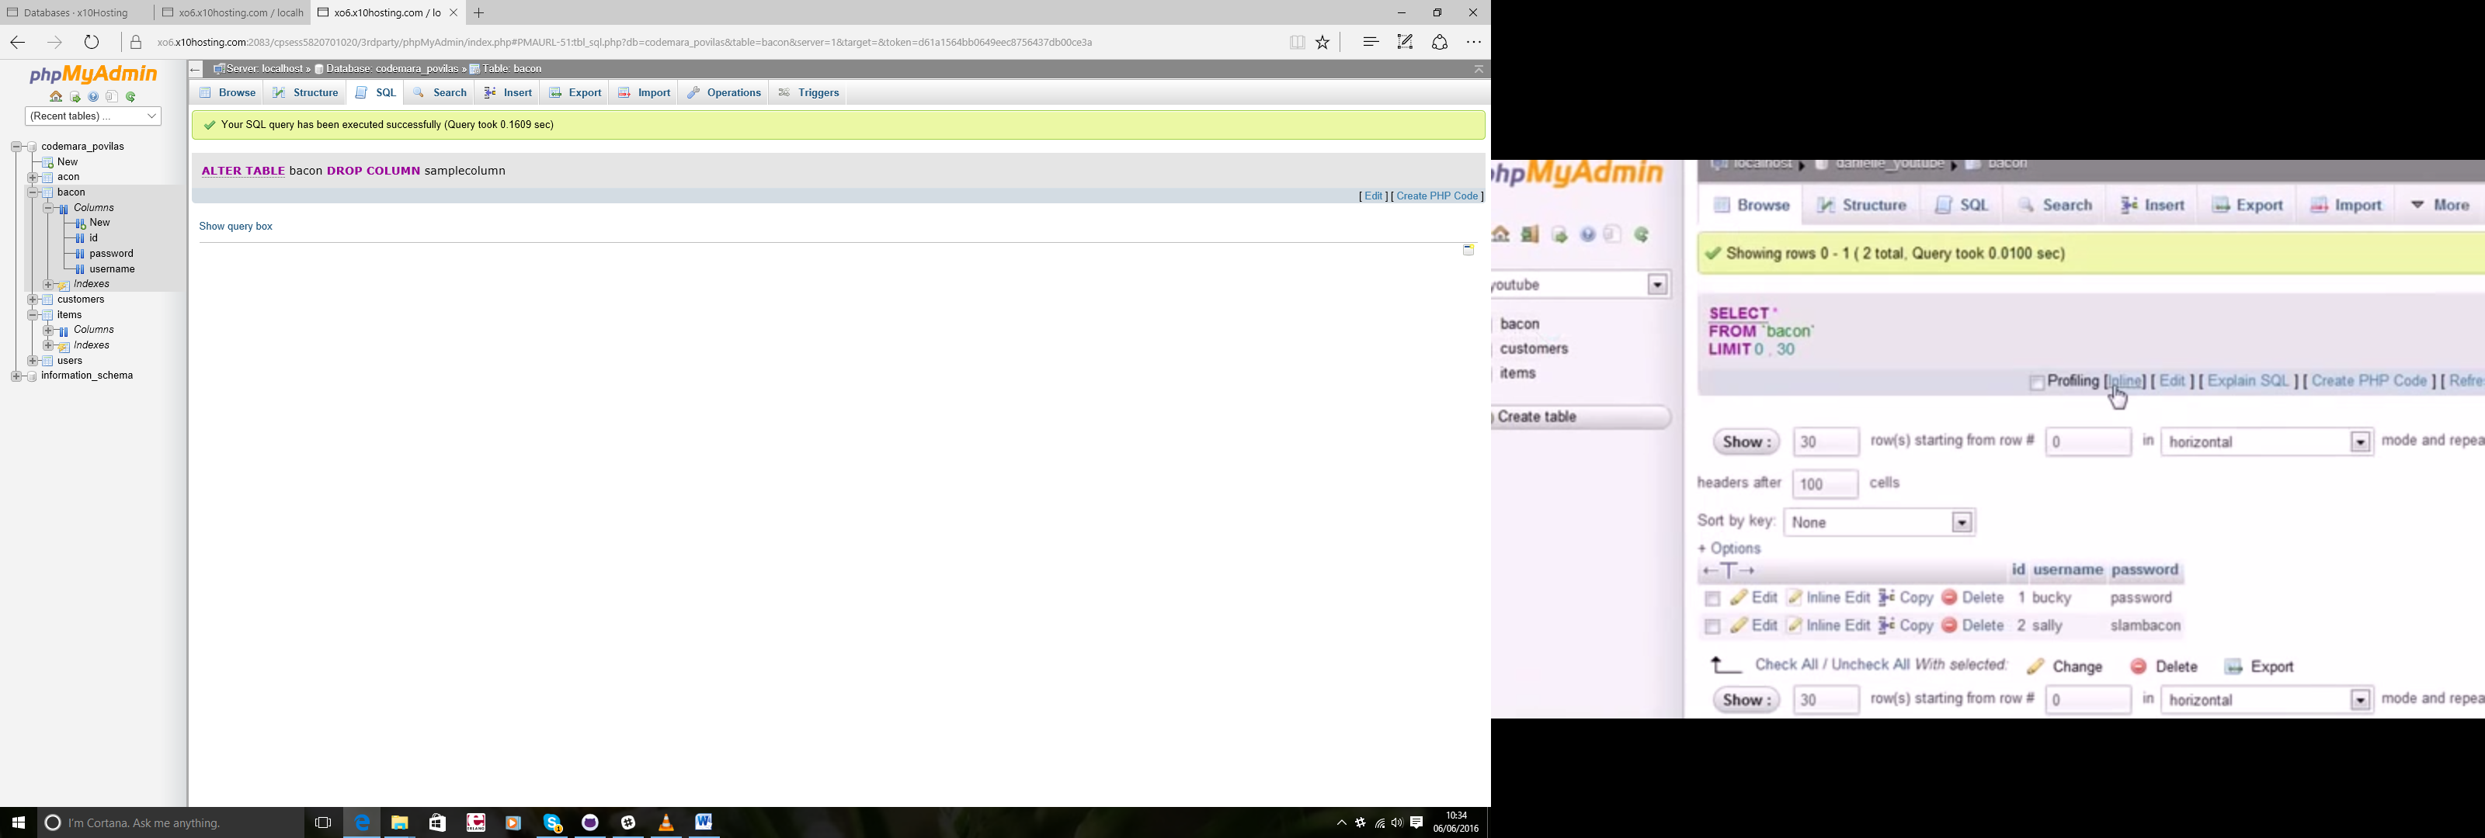

DROP TABLE bacon

*Delete table*

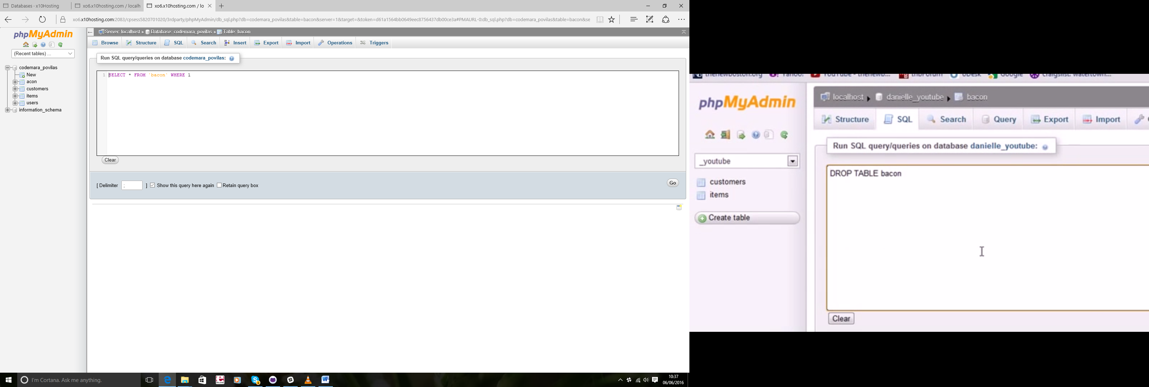

RENAME TABLE

RENAME TABLE customers TO users1

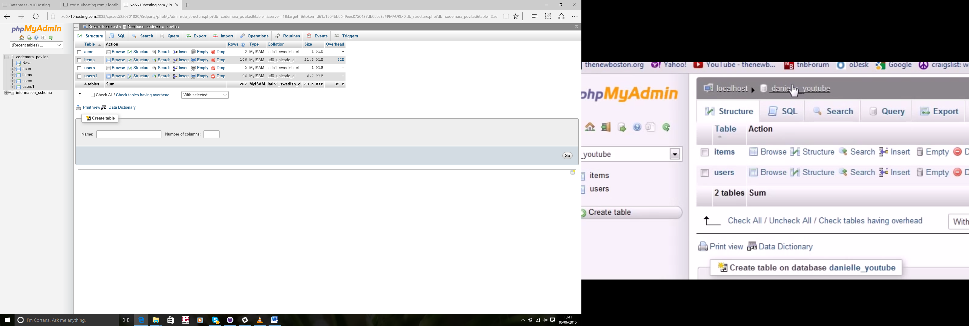

## 32 – View

They like temporary table

SELECT id,name,bids FROM items ORDER BY bids DESC LIMIT 10

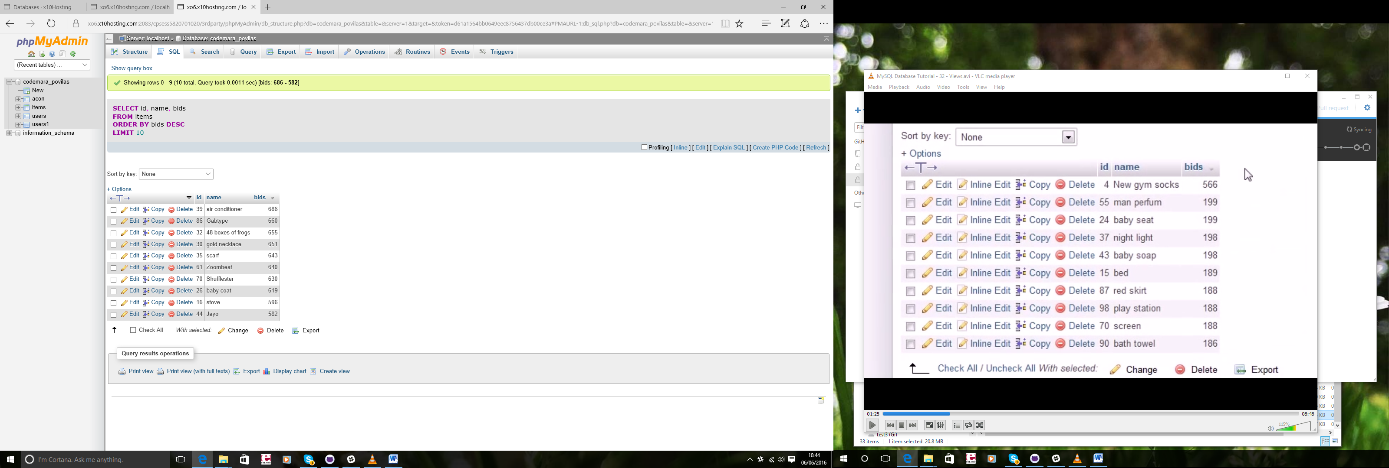

CREATE VIEW mostbids AS

SELECT id,name,bids FROM items ORDER BY bids DESC LIMIT 10

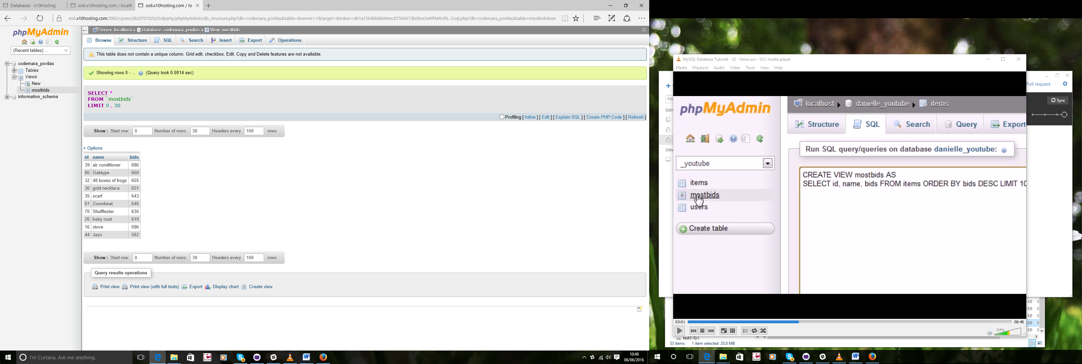

SELECT Concat(city,',',state) AS address from users1

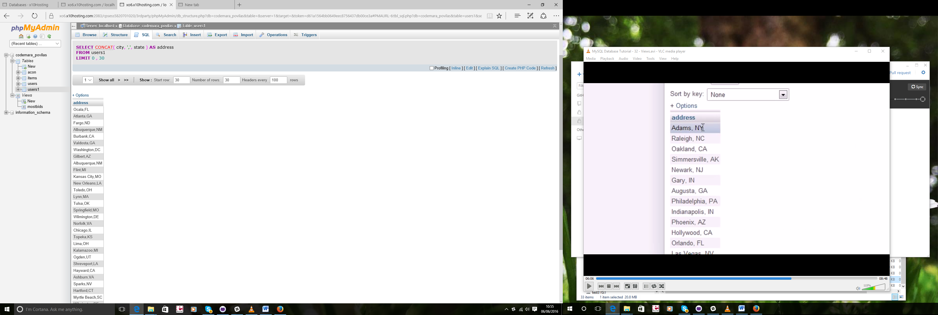

CREATE VIEW mailing AS

SELECT Concat(city,',',state) AS address from users1

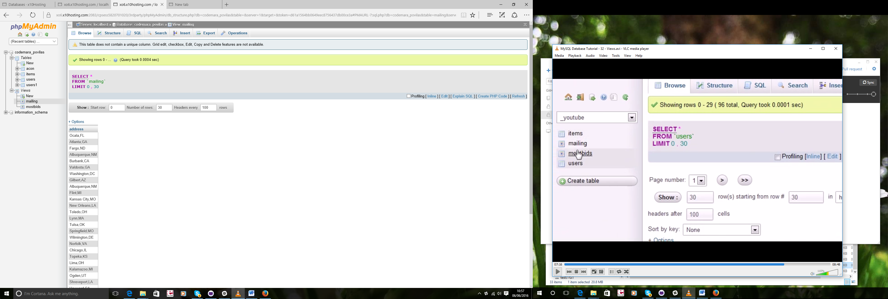

SELECT name ,bids FROM mostbids

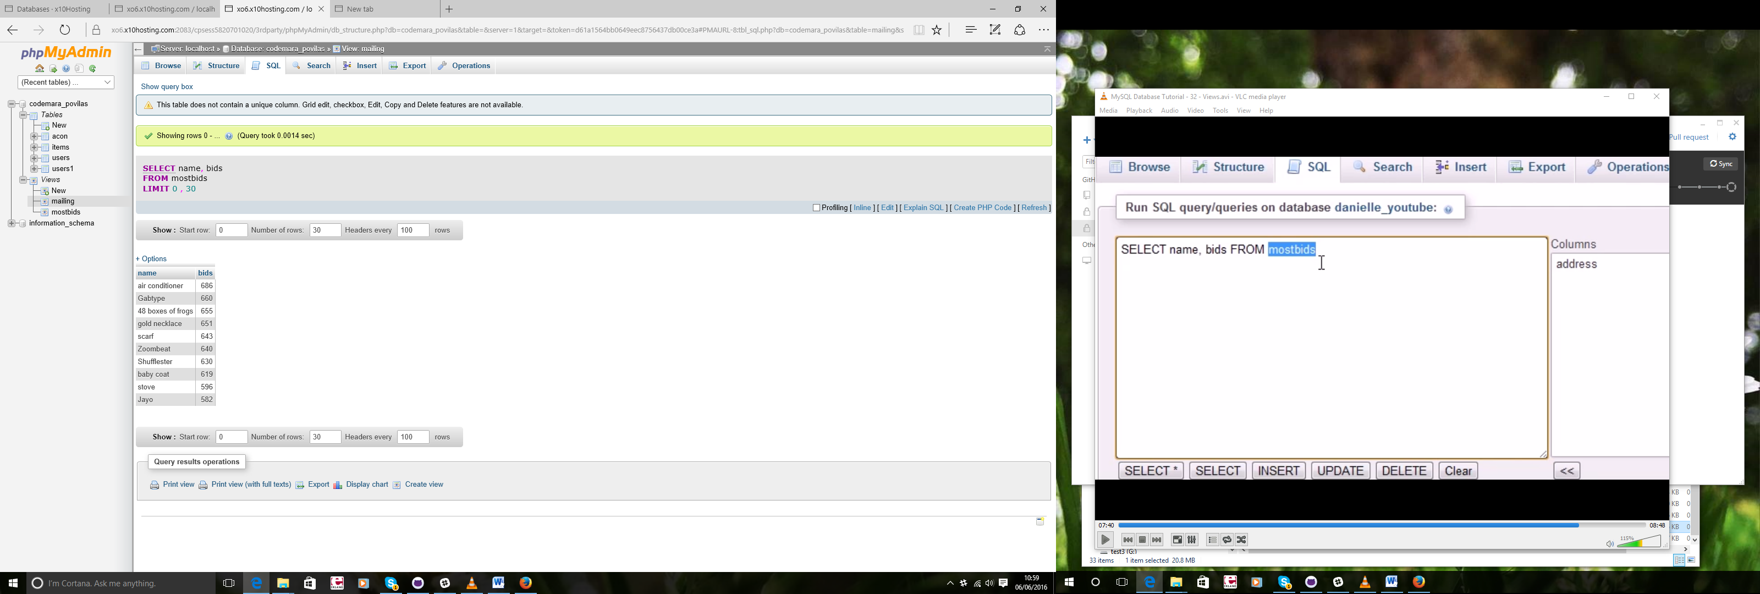

## 33 - Final

Save database

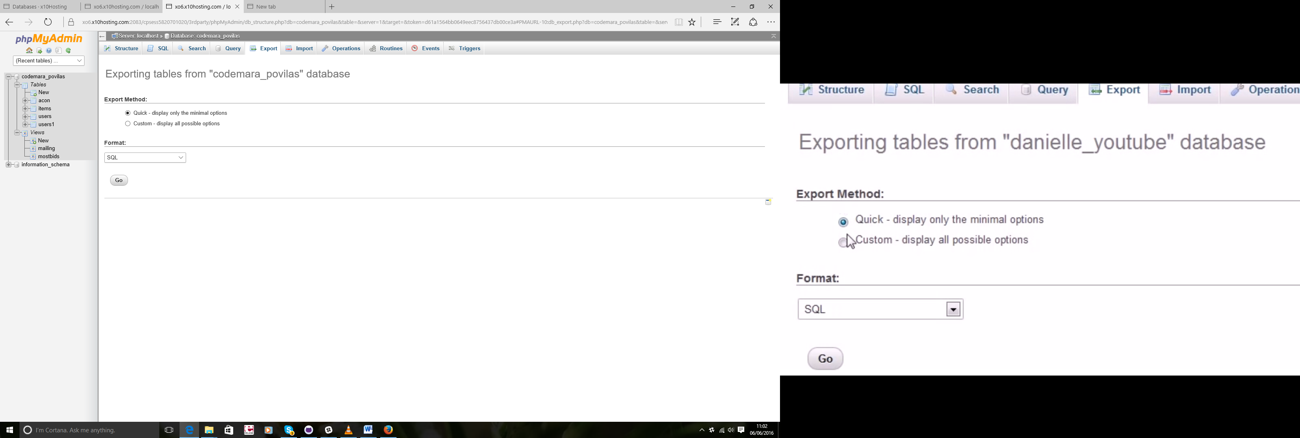

Never use SELECT ALL

Never get more data when u actually need

FULLTEXT >LIKE